

Report
The Development of an Interactive and Educational Mini Factory for Children and Students at The Chocolate Factory
The Chocolate Factory, Veghel

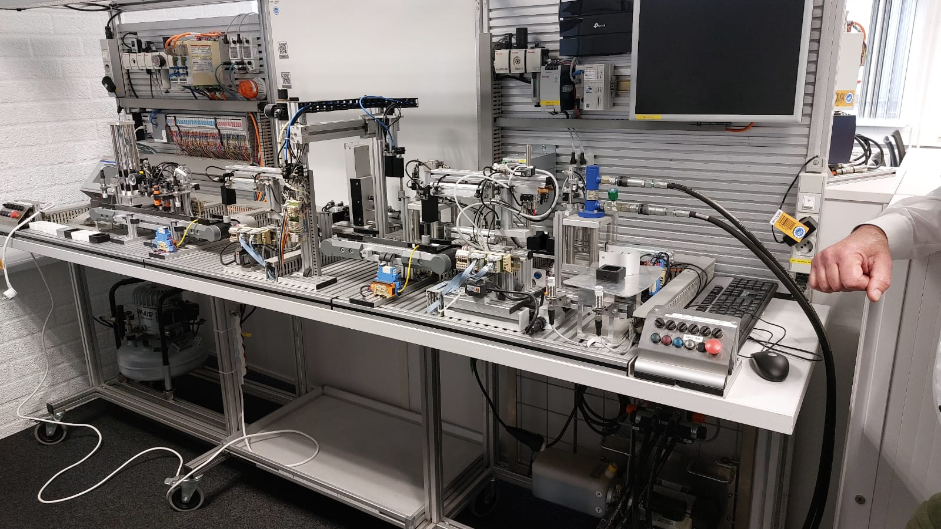
Author(s)
Anastasiia POLIMASHEVA

Revision
0000, 06-MAY-2025
Project number

General
Project name | : | The Development of an Interactive and Educational Mini Factory for Children and Students at The Chocolate Factory
Reference Actemium | :
Reference Customer | :
Reference End User | :
Customer | : | The Chocolate Factory
Address | : | Verlengde Noordkade 14 5462 EC Veghel
Postal address | : | PO Box
Telephone | : | +31 6 155 252 96
Contact | : | Bart Coppes (bart.c@thechocolatefactory.nl)
End User | : | The Chocolate Factory
Address | : | Verlengde Noordkade 14 5462 EC Veghel
Postal address | : | PO Box
Telephone | : | +31 6 155 252 96
Contact | : | Bart Coppes (bart.c@thechocolatefactory.nl)
Contractor | : | PSZO BV
Address | : | Poort van Veghel 4940 5466 SB Veghel
Postal address | : | PO Box 248 5460 AE Veghel
Telephone | : | +31 88 831 89 99
Contact | : | Ard HENDRIKSON (ard.hendrikson@actemium.com)

Author | : | Anastasiia Polimasheva
Student number | : | 4743911
Educational institute | : | Fontys University of Applied Science
Study program | : | Mechatronics
Class | : | MC5INTRN
Email | : | 102750@student.fontys.nl

Approval

Actemium | Name | Function | Signature / Date
Written by | Anastasiia POLIMASHEVA
Approved by | Ard Hedrikson

Customer | Name | Function | Signature / Date
Approved by | Bart Coppes
Approved by
Authorized by

End User | Name | Function | Signature / Date
Approved by | Mark Herman
Approved by
Authorized by

Distribution List

Revision | Date | To | Company
0000 | 27/05/2025 | Ard Hedrikson | Actemium

Document History

Revision | Date | Details | Author
0000 | 07/05/2025 | Intermediate report submission | Anastasiia Polimasheva

Preface
This report presents the results of my internship at Actemium’s EduLab. Project was located within The Chocolate Factory in Veghel and was developed for their museum. The goal of this assignment was to transform the Bosch Rexroth Mini Factory—an industrial automation system—into a safe, educational, and interactive experience tailored for young visitors and students. Set up was provided by Bosch Rexroth and was used before to train future engineers to work with Bosch`s components and systems. Over the course of this project, I collaborated with engineers from Bosch Rexroth, educators from different schools, and students from different educational institutes from North-Brabant region to design and implement various operational modes, integrate child-friendly hardware and interfaces, and ensure safety and engagement across different user levels. On this project together with me was working MBO student from Koning Willem I College who is completing his graduation this year. While my work was more analysing and designing, he took on himself heavy lifting of rewiring, ordering components and assembly.

This report is intended for a diverse audience. Engineers and technical readers can use it to understand the design rationale, system requirements, and implementation details. Educators and museum staff may benefit from the user experience design, programming interfaces, and teaching opportunities described. Finally, future students and interns may find this document useful as a guide for continuing work or replicating a similar project.

I would like to express my sincere gratitude to my mentor Ard Hendrikson for his valuable guidance and patience throughout the internship. My appreciation also goes to the Actemium team, Bosch Rexroth collaborators, and the staff at The Chocolate Factory for providing resources and support. Special thanks to my academic supervisor Mark Herman for providing me with support and fast replies to my questions. A lot of thanks to my peers at Fontys University of Applied Sciences for their encouragement and critical feedback. And last but not the least, I would like to express my gratitude to person who helped me to find this project and made it possible to happen – Max Bogers.

Veghel, May 2025
Anastasiia Polimasheva

Summary
Automation and interactive learning are reshaping the way education intersects with industry, particularly in public settings such as museums. In response to this trend, Actemium initiated a project to transform the Bosch Rexroth Mini Factory—an industrial training system located at The Chocolate Factory in Veghel—into an engaging, educational exhibit for children aged 8 and above. The original system, while highly effective for professional training, was too complex, unengaging, and unsafe for younger users.
The primary objective of this project was to redesign the Mini Factory into a multi-functional, child-friendly experience while preserving its core automation capabilities. Key requirements included simplifying the user interface, integrating visual programming tools (Scratch and JavaScript), implementing multi-mode operation (e.g., demo, leisure, educational modes), and ensuring compliance with child safety standards. These goals were driven by clearly defined user requirements gathered through collaboration with stakeholders and structured using the MoSCoW prioritization method.
The project followed the Fontys V-model methodology, which structured the development process from initial requirement analysis through design, development, and testing. Mechanical adaptations were made to make the system physically intuitive and safe, while new software features allowed for customizable and gamified user interactions. A web-based interface was chosen for its flexibility, scalability, and future-proof potential. Safety, engagement, and accessibility were central to each design decision.
The final result is a fully adapted system that allows children to interact with the Mini Factory in a safe, structured, and educational way. The deliverables include redesigned hardware components, custom-developed interfaces, and comprehensive documentation for future use. The new system supports multiple user types, from casual visitors to workshop students, providing them with a hands-on introduction to automation and programming.
In conclusion, this project successfully bridges industrial automation and educational engagement. It demonstrates that with thoughtful design and clear user-centered goals, even highly technical systems can be made accessible and exciting for younger audiences. It is recommended that future projects expand on this framework by integrating data tracking for user behavior and exploring additional programming languages to extend the system's educational reach.

Table of Contents
General 2
Approval 3
Distribution List 3
Document History 4
Preface 5
Summary 6
References 8
1 Chapter 1: Introduction 10
2 Chapter 2: Project Definition 11
3 Chapter 3: Functional decomposition and System requirements 17
4 Chapter 4: Risk assessment and Safety Implementation 23
5 Chapter 4: Improvements to the existing system 50
6 Chapter 6: Software design 54
7 Chapter 7: Testing and Validation Plans 63
8 Chapter 8: Conclusion and recommendations 68
9 Appendix A: Fontys V-Model 70
10 Appendix B: Documentation and Demonstration Links 72
11 Appendix C: Explanation of the MoSCoW Prioritization Method 73
12 Appendix D: Functional Decomposition Based on ISA-88 74
13 Appendix E: ISA-88 model 79
14 Appendix F: FMEA risk assessment 81
15 Appendix G: Risk assessment Table (ISO 12100) 82
16 Appendix H: Maintenance Forms and Reports 87
17 Appendix I: User story 90
18 Appendix J: Pages design 91

References

Related Documents
Fontys University of Applied Sciences. (n.d.). Project Methodologies: Fontys V-Model [Internal course material].
Fontys University of Applied Sciences. (n.d.). Project Methodologies: User Story [Internal course material].
123456-URS-0100-UserRequirements. User Requirements Specification for Interactive Educational Automation Exhibit.
123456-FDS-0100-FunctionalDesign. Hardware Design Specification – Modified Components and 3D Models.
123456-RAR-0100-RiskAssessmentReport. Safety Design Specification – Risk Assessment, Preventive Actions, Design of the Components.
Vos, P. (2025, March 5). Proeve van bekwaamheid: Moderniseren van de Bosch Rexroth Trainer – Puc.

Applied Standards
International Electrotechnical Commission. (1997). IEC 61512-1: Batch Control – Part 1: Models and Terminology (Also referenced as ISA88.01).
International Organization for Standardization. (2010). ISO 12100: Safety of Machinery – General Principles for Design – Risk Assessment and Risk Reduction.
International Electrotechnical Commission. (2018). IEC 60204-1: Safety of Machinery – Electrical Equipment of Machines – Part 1: General Requirements.
International Organization for Standardization. (2015). ISO 13849-1: Safety of Machinery – Safety-Related Parts of Control Systems – General Principles for Design.
International Organization for Standardization. (2015). ISO 14119: Safety of Machinery – Interlocking Devices Associated with Guards – Principles for Design and Selection.
International Organization for Standardization. (2019). ISO 13857: Safety of Machinery – Safety Distances to Prevent Hazard Zones Being Reached by Upper and Lower Limbs.
International Organization for Standardization. (2015). ISO 13855: Safety of Machinery – Positioning of Safeguards with Respect to the Approach Speeds of Parts of the Human Body.
International Electrotechnical Commission. (2021). IEC 62061: Safety of Machinery – Functional Safety of Safety-Related Control Systems.

Literature
Norman, D. A. (2013). The Design of Everyday Things. MIT Press.

Papert, S. (1980). Mindstorms: Children, Computers, and Powerful Ideas. Basic Books.

Resnick, M., Maloney, J., Monroy-Hernández, A., Rusk, N., Eastmond, E., Brennan, K., ... & Kafai, Y. (2009). Scratch: Programming for All. Communications of the ACM, 52(11), 60–67. https://doi.org/10.1145/1592761.1592779

ISO/IEC. (2014). Guide 71: Guidelines for Standards Developers to Address the Needs of Older Persons and Persons with Disabilities.

Clegg, D., & Barker, R. (1994). Case Method Fast-Track: A RAD Approach. Addison-Wesley.

Stamatis, D. H. (2003). Failure Mode and Effect Analysis: FMEA from Theory to Execution. ASQ Quality Press.

Organisation for Economic Co-operation and Development. (2019). 21st-Century Children: Digital Technologies and Learning. OECD Publishing. https://doi.org/10.1787/b7e2e3d0-en

Bosch Rexroth GmbH. (2020). Mini Factory – Learning System Manual. Lohr am Main.

Bosch Rexroth. (n.d.). ctrlX CORE Platform Overview. https://www.boschrexroth.com/

Christiani. (n.d.). Educational Modules Overview. https://www.christiani.de/

Chapter 1: Introduction

Automation and interactive learning are rapidly reshaping the way industries engage with education and public outreach. In line with this, Actemium, a global leader in industrial automation and system integration, has undertaken an initiative to enhance interactive learning experiences at The Chocolate Factory in Veghel, Netherlands. This project centers around the Bosch Rexroth Mini Factory, a fully automated production system designed to simulate real-world manufacturing processes using hydraulics, pneumatics, sensors, and a Programmable Logic Controller (PLC).
The current setup of the Bosch Rexroth Mini Factory, however, is primarily designed for industrial and professional training purposes, making it less accessible to younger audiences. The challenge lies in transforming this system into an interactive and educational exhibit that is safe, engaging, and suitable for children aged 8 and above. The objective of this internship project is to develop a multi-functional experience that allows various user groups, including students, museum visitors, and workshop participants, to engage with automation technology in an intuitive and educational manner.
To achieve this, the project follows a V-model design model (Appendix A), integrating mechanical, electrical, and software development disciplines. The key aspects include adapting the hardware to be child-friendly, implementing different operational modes to cater to varied user groups, developing an interactive programming environment with Scratch and Python, and enhancing the overall user experience through improved aesthetics and interface design. Safety considerations and educational effectiveness are central to this transformation.
This report is structured to follow the full lifecycle of the internship project, beginning with an introduction to the context and goals of the initiative. The second main chapter after introduction, Project Definition, outlines the background, scope, and objectives of transforming the Bosch Rexroth Mini Factory into an interactive educational exhibit. This is followed by a detailed exploration of the system’s architecture in Chapter 3, which covers functional decomposition, the function tree, and the definition of system requirements. Chapter 4 addresses risk assessment and safety considerations, focusing on how safety measures were identified and integrated to make the system suitable for younger users. Chapter 5 presents the improvements made to the existing system, including mechanical, electrical, and user-experience enhancements. The final chapter, Chapter 6, delves into the software design, describing the integration of Scratch and Python programming environments and how different operational modes were implemented to suit various audiences. Supporting materials and technical references are provided in the appendices, including diagrams, risk assessment documentation, and educational tools. Testing procedure will be covered in a different report outside of scope of this internship.
For readers seeking a complete understanding of the project and its development process, the report is best read in sequential order. However, those with specific interests—such as risk management, software design, or educational strategy—may choose to focus directly on the relevant chapters or appendices. Main information about the project is contained in Summary, that covers background, approach, results and conclusions, and Conclusions, that cover project results.

Chapter 2: Project Definition
This chapter provides a detailed definition of the project, outlining the current situation, technical challenges, and the specific objectives that must be achieved to meet the client’s expectations. It begins with background information describing the limitations of the existing system and the need for improvement, followed by a clear technical problem definition. The design brief outlines the intended transformation, detailing the difference between the current and desired states. The chapter also presents a summary of the project’s expected deliverables, a comprehensive set of user requirements categorized using the MoSCoW method, the chosen project approach, and the defined project scope, including key constraints and boundaries. Later in Chapter 2 these user requirements and project boundaries are translated into system requirements to define specific and achievable goals and be the basis of the final testing plan.

Background Information
The Bosch Rexroth Mini Factory, currently located in The Chocolate Factory — a new children’s museum in Veghel — was originally developed five years ago to train professional engineers using Bosch Rexroth automation systems. It features industrial-grade components including Bosch Rexroth PLCs, I/O modules, and pneumatic control logic. The installation was initiated through a collaboration between Actemium’s EduLab department and the museum, with the goal of introducing children to modern technology and encouraging early interest in STEM (Science, Technology, Engineering, and Mathematics).
Although the core system is robust, it was never designed for public interaction by children. It lacks user-friendly interfaces, has no beginner-level programming environment, and offers minimal guidance or engagement for non-professional users. Its operational documentation is limited to German datasheets for individual submodules, which were originally supplied by Christiani — a German company known for producing modular educational systems. These materials are available in the main project GitHub repository (see Appendix B).
Furthermore, parts of the setup — including rewiring and development of an electrical schematic — were completed by a vocational student from Konning Willem College in Oss. This highlights the collaborative and educational nature of the initiative. However, the system remains technically complex and largely inaccessible to its intended young audience. Visitors, particularly children and their families, often struggle to understand or interact with the system effectively. Educators and museum facilitators also face challenges in integrating the system into structured workshops or interactive exhibits.
As a result, the Mini Factory remains underutilized in its current form, with potential safety risks for younger users and limited educational value without further adaptation. Additionally, since the project is fund-based, only components and modifications within budget limitations will be implemented during this phase. The report will therefore focus on functional redesign and technical documentation for both implemented and future upgrades, particularly for parts deemed too expensive for immediate procurement.

Technical Problem Definition
The primary technical problem revolves around adapting an industrial system into an intuitive, educational, and interactive learning tool while maintaining its core functionality. The key challenges include:
- Lack of intuitive user interfaces: The current control system is too complex for children and casual museum visitors.
- Limited educational programming: There are no beginner-friendly coding environments integrated into the system.
- Safety concerns: The system is not designed with child-friendly safety features, posing risks in a public setting.
- Lack of engaging interactive features: The Mini Factory does not currently include elements that captivate younger audiences.
- One-mode operation: The system lacks different operational modes tailored to diverse user groups, restricting its usability.
These issues occur primarily when children, museum visitors, or educators attempt to interact with the system but find it too complex, unsafe, or unengaging. The absence of suitable controls and programming environments prevents it from fulfilling its potential as an educational exhibit.

Design Brief
The project aims to bridge the gap between industrial training and interactive STEM education by modifying the Bosch Rexroth Mini Factory. Factory hardware is mainly done together with a normal operational mode and was used before. All the components, schematics, documentation and operational video are created during this project and can be found in Appendix B. The expected outcome is an adapted system that retains its industrial capabilities while introducing intuitive user interfaces, educational programming, and engaging features. The client will consider the project successful when:

The system allows seamless interaction for children aged 8+ without the need for extensive guidance.

Multiple operational modes (Demo Mode, Leisure Mode, Learning Mode) are implemented to cater to different user groups.

The system includes a safe, structured, and interactive programming interface suitable for beginners.

Safety measures are in place to ensure compliance with child-friendly usage standards.

The factory’s design is visually engaging and enhances user experience.

Assignment Definition
The core assignment for this internship focuses on transforming the Bosch Rexroth Mini Factory into an engaging, educational exhibit tailored to young museum visitors. This involves interpreting the client's vision, identifying the needs of target users, and proposing a functional design that improves usability, safety, and engagement — without modifying the core industrial training setup beyond its educational intent.
The specific objectives of this assignment include:
- User Research & Narrative Development: Investigating the expectations, behaviors, and preferences of children aged 8+ to create a compelling background story and mission for the exhibit. This storyline will serve as a narrative framework to motivate children to interact with the installation and learn fundamental STEM principles.
- Safety Design: Identifying potential risks in the current system and proposing design solutions that make the interaction child-safe. This includes evaluating physical access, operational hazards, and control logic behavior.
- Concept Development for Engagement Modules: Designing visual, physical, and interactive add-ons to make the system more attractive and intuitive to use. Due to the limited project budget, only conceptual designs and assembly-ready documentation will be developed, with real-world manufacturing and deployment considered out of scope.
- Software Research & Interface Development: Exploring suitable programming environments (e.g., Scratch, JavaScript) that can be layered on top of the existing system to allow different types of users (children, educators, developers) to interact with the Mini Factory. Where feasible, the project will also involve developing custom web-based interfaces and documenting these for future engineers.
- Future Integration with PLC: If the delivery of a new Bosch Rexroth PLC occurs within the internship period, the newly developed interfaces will be tested and deployed on this system. However, due to budget constraints and hardware availability, this step remains optional and dependent on external factors.
This project is fund-based, which means all physical implementation is conditional upon future funding or part availability. Therefore, this internship primarily focuses on design, technical documentation, safety analysis, software interface prototyping, and ensuring that future engineers can continue this work with minimal onboarding.

Project Result
At the end of the project, the following deliverables will be provided to Actemium and the EduLab team:
- A functionally adapted Mini Factory concept that includes detailed proposals for child-friendly interaction, engagement, and safety, based on user needs and site observations. This does not include full hardware implementation due to budget constraints but presents a tested and ready-to-deploy design.
- Prototypes of digital control interfaces, including:
  - A Scratch-based programming interface for young users.
  - A JavaScript-based interface for more advanced interaction.
  - Web-based control UI mock-ups and interaction flows.
  - Detailed documentation to allow future developers to take over and further implement these interfaces.
- Defined operational modes tailored to multiple visitor groups:
  - Demo Mode for exhibitions and guided tours.
  - Leisure Mode for casual exploration.
  - Learning Modes 1 & 2 for structured educational activities.
- Safety assessment and redesign proposals addressing known risks with child-focused safeguards (e.g., emergency stop accessibility, restricted zones, and safe input devices), including engineering documentation and compliance checks against public safety expectations.
- Concept designs for engaging physical modules, such as visual add-ons or control components (e.g., joysticks, buttons, haptic elements). While physical manufacturing is not included in this phase, all CAD files, wiring diagrams, and bill of materials will be prepared for future use.
- Comprehensive technical documentation, provided via the main GitHub repository and in a structured report format, including:
  - A user manual with setup and operational instructions.
  - Software development and configuration guide.
  - Electrical schematics and wiring documentation.
  - Interface implementation guide for future engineers.
  - Testing plans and validation steps for future deployment phases.

User Requirements (UR)
This section outlines the specific user requirements and project boundaries that are taken from user story and client's wishes (Table 2.6.1). All the user requirements will be graded according to the MoSCoW model priority system evaluation and can be seen by the colour code (red - Must; orange - Should, yellow - Could and blue - Won`t) or third column on each user requirements table, where M refers to Must, S refers to Should, C refers to Could and W - to Won`t (see Appendix C).

Table 2.6.1 User requirements graded using MoSCoW
Num. | Description | MoSCoW
UR1 | Execution of the project must align with safety standards of Actemium and The Chocolate Factory | M
UR2 | Safety compliance for children aged 8+ | M
UR3 | Interactive user controls (buttons, touchscreens, joysticks) | M
UR4 | Scratch-based programming interface for beginners | M
UR5 | JavaScript programming capabilities for advanced users | M
UR6 | Multiple operational modes (industrial, demo, leisure, educational) | M
UR7 | Comprehensive user manual or/and instructions on exposition on how-to-use a system | M
UR8 | Appealing design integrated with exposition and user story | M
UR9 | User-friendly visual interface and improved aesthetics | M
UR10 | All additional components should be easy to design within facilities of Chocolate Factory or/and Actemium. Approval needed. | M
UR11 | Intuitive step-by-step tutorials integrated into the system | S
UR12 | Gamification elements to enhance engagement | S
UR13 | Real-time feedback mechanisms for users | S
UR14 | Multi-language support for educational materials | S
UR15 | Option for integration or Integration with external educational platforms | C
UR16 | Mobile application support for remote interaction | C
UR17 | Monitoring system of general users’ activity for a general management system | C
UR18 | Additional physical interaction components (e.g., haptic feedback devices) | C
UR19 | Additional support of other programming languages for educational use | C
UR20 | Full redesign of existing mechanical hardware beyond minor modifications | W
UR21 | Development of entirely new hardware components | W
UR22 | Expansion beyond the current location of The Chocolate Factory | W
UR23 | Integration with advanced industrial automation tools not suited for educational purposes | W

Project Boundaries
This project focuses on improving the educational and interactive aspects of the Mini Factory while maintaining its industrial training functionality. The following aspects are out of scope:
- Redesigning the complete mechanical system.
- Developing new industrial automation processes beyond educational interactions.
- Implementing VR/AR solutions.
- Creating a fully autonomous AI-driven operation.
- Conducting large-scale user studies beyond test groups.

The system deployment in museum and post-employment report
This development will be carried out using available hardware and open-source tools whenever possible, ensuring that the absence of a fixed budget does not hinder the delivery of a complete conceptual and technical solution.

Project Approach
The project will follow the Fontys V-Model methodology to ensure a structured development and validation process. The approach consists of the following phases:
- Requirement Analysis:
  - Define project scope, objectives, and user needs.
  - Gather and analyze all relevant technical and functional requirements.
  - Establish a detailed requirements specification document.
- System Requirements:
  - Translate user needs into system requirements using the SMART methodology.
  - Develop a testing and validation plan based on defined requirements.
- System Design:
  - Develop the architecture, components, and workflows of the system.
  - Create high-level and low-level design documents, including interface specifications.
- Module Design:
  - Break down system design into smaller functional components.
  - Define detailed module-level designs and mock-ups.
- Moduling & Development:
  - Develop system components according to design specifications.
  - Implement all planned functionalities and ensure seamless integration.
- Module Testing:
  - Test individual system components to verify correct functionality.
  - Address any detected issues before system integration.
- System Testing:
  - Validate the entire system against original requirements in a controlled environment.
  - Conduct usability tests to ensure functionality and engagement.
- Acceptance Testing:
  - Perform final validation with stakeholders and end-users.
  - Confirm system readiness for deployment and finalize documentation.

Conclusion Chapter 2
The Bosch Rexroth MiniFactory project was redefined to serve a new educational audience: children aged 8 to 18. Through extensive stakeholder consultation and requirement gathering, a structured framework of user, system, and safety requirements was established. These requirements now guide all developments, ensuring that technical upgrades remain aligned with pedagogical goals and safety standards. The project scope was realistically framed within the internship duration, ensuring feasibility while allowing for modular expansion.

Chapter 3: Functional decomposition and System requirements
Translation of the client’s needs that were defined in Chapter 1 into precise technical functions and system requirements are defining what the final design must achieve. It begins with a functional decomposition, a hierarchical breakdown that maps out each subsystem's role and its interaction within the larger system architecture. Accompanying this, specific design criteria are outlined, addressing aspects such as safety, performance, and maintainability. Later these system requirements will be used to create a test plan and used as a main guideline during system design in Chapters 3, 4 and 5. The chapter concludes with detailed system requirements, categorized into software, mechanical, and electronic domains.

Functional decomposition
Since the Mini Factory was originally developed as an industrial batch process system, a functional decomposition based on the ISA-88 (IEC 61512) standard is used to divide the setup into clearly defined systems and subsystems. This internationally recognized model provides a hierarchical structure for batch control systems, organizing the architecture into enterprise, site, area, process cell, unit, equipment module, and control module levels.
Instead of a generic function tree, this decomposition method is tailored to reflect the factory’s real-world automation hierarchy and how its physical and logical components interact. This structured approach makes it easier to map, document, and modify subsystems individually.
Functional decomposition is especially useful for this project because it:
- Clarifies system architecture for future engineers, supporting maintainability and modular upgrades.
- Aligns with real-world industrial logic, which is critical for preserving the educational and professional relevance of the system.
- Supports targeted redesign, enabling the safe and effective adaptation of specific components for children’s interaction.
- Forms the basis for safety and testing plans, as each module's function and risks can be isolated.
A complete system breakdown based on this decomposition is presented in Appendix D, while additional information about the ISA-88 model and its structure is provided in Appendix E.

System Requirements
This section defines the System Requirements (SRs) necessary to implement the project goals outlined in Chapter 2. These requirements are derived from the previously established User Requirements (URs) — particularly those listed in Table 2.6.1 — and from the defined project boundaries. The purpose of this section is to translate what users need into what the system must technically deliver, using terminology and structure suitable for engineers and developers.
Each requirement is assigned a priority level using the MoSCoW method, where:
- M – Must: Critical features necessary for system success (red colored)
- S – Should: Important but not essential features (orange colored)
- C – Could: Desirable features if time/resources allow (yellow colored)
- W – Won’t: Out-of-scope or explicitly excluded features (blue colored)
These priorities help guide development decisions and resource allocation, especially in this fund-limited project. The requirements are organized into four domains:
- Software System Requirements (SSR)
- Mechanical System Requirements (MSR)
- Electronics System Requirements (ESR)
- Testing and Integration System Requirements (TSR)
To ensure transparency and traceability, each section includes a UR ➝ SR traceability matrix that maps user requirements to corresponding system-level implementations. This traceability ensures all user expectations are considered in the design and will form the foundation of the testing and validation plan in Chapter 6.

3.2.1 Software Requirements
This section describes System requirements (Table 3.2.1.1) for Software of the system and are referred here and further as SSR which stands for “Software System Requirements”. Includes traceability matrix between User requirements and System requirements (Table 3.2.1.2).

Table 3.2.1.1 Software System Requirements graded using MoSCoW method
Num. | Description | MoSCoW
SSR.1 | The background story of the Mini Factory should be created for children’s engagement (what are children producing in the factory and what is the goal of programming this factory?). | M
SSR.2 | The system shall support multiple operational modes: Demo Mode, Leisure Mode, Learning Mode. More modes can/should be implemented to enhance user experience. | M
SSR.3 | The system shall include an intuitive graphical user interface (GUI) accessible via touchscreen and/or web-based applications. | M
SSR.4 | The educational programming environment shall support block-based coding (Scratch) and at least one text-based coding language (Python, C++ or JavaScript). | M
SSR.5 | The system shall store and retrieve user-created programs and settings for repeated use. | S
SSR.6 | Safety protocols shall be implemented in the software to prevent unauthorized or unsafe operations. | S
SSR.7 | The system shall provide real-time feedback and diagnostics, including error messages, system status, and educational insights. | S
SSR.8 | The software shall enable remote monitoring and control by educators through a secured access channel. | C
SSR.9 | The system shall comply with cybersecurity standards to ensure data protection and prevent unauthorized access. | C
SSR.10 | The system will not include VR/AR interfaces or simulations as part of the user experience. | W
SSR.11 | Fully autonomous AI-based decision making is not planned or implemented. | W
SSR.12 | The developed software shall not be deployed to the core control system unless the required hardware (PLC or equivalent) is delivered within the project timeframe. | W

Table 3.2.1.2 UR ➝ SSR Traceability Matrix (Software)
User Requirement (UR) | Description | Corresponding Software System Requirements (SSR)
UR1 | Safety compliance for children aged 8+ | SSR.6, SSR.7
UR2 | Multiple operational modes | SSR.2
UR4 | Scratch-based programming interface | SSR.4
UR5 | JavaScript programming capabilities | SSR.4
UR6 | Visual GUI and control interface | SSR.3
UR11 | Step-by-step tutorials | SSR.7
UR13 | Real-time feedback mechanisms | SSR.7
UR15 | Integration with external platforms | SSR.8, SSR.9
UR22 | No AR/VR development | SSR.10
UR23 | No AI-based automation | SSR.11

3.2.2 Mechanical Requirements
This section describes System requirements (Table 3.2.2.1) for Mechanical parts of the system and are referred here and further as MSR which stands for “Mechanical System Requirements”. Includes traceability matrix between User requirements and System requirements (Table 3.2.2.2).

Table 3.2.2.1 Mechanical System Requirements graded using MoSCoW method
Num. | Description | MoSCoW
MSR.1 | System must be updated to follow all safety standards for installation in the museum and usage by children. This will be created in collaboration with a Safety specialist. | M
MSR.2 | The Mini Factory’s physical structure shall be modified to engage younger age groups and motivate to work with the system. | M
MSR.3 | The system shall include user-friendly control elements, which are supposed to be valid according to the background story for children’s engagement. | M
MSR.4 | The structural modifications shall maintain compatibility with the original industrial automation framework. | M
MSR.5 | All additional components that need to be purchased need to be approved by the client. | M
MSR.6 | The mechanical components shall be modular, allowing for easy upgrades and future expansion. | S
MSR.7 | The system shall withstand frequent use in a public environment with minimal maintenance requirements. If hardware at the start restricts this SR, it may be eliminated. | S
MSR.8 | The factory layout shall be optimized for museum and public space installation, ensuring accessibility and visibility. | C
MSR.9 | A complete mechanical redesign of the Mini Factory beyond minor physical modifications is out of scope. | W
MSR.10 | No new hardware components will be manufactured within this project due to budget limitations. | W

Table 3.2.2.2 UR ➝ MSR Traceability Matrix (Mechanical)
User Requirement (UR) | Description | Corresponding Mechanical System Requirements (MSR)
UR2 | Safety for children aged 8+ | MSR.1
UR3 | User-friendly control elements | MSR.3
UR8 | Appealing and engaging design | MSR.2
UR10 | Component compatibility with local facilities | MSR.5
UR20 | No full redesign of hardware | MSR.4
UR12 | Gamified physical engagement (optional) | MSR.6
UR20 | No full redesign of mechanical hardware | MSR.9
UR21 | No development of new hardware | MSR.10

3.2.3 Electronic Requirements
This section describes System requirements (Table 3.2.3.1) for Electronics of the system and are referred here and further as ESR which stands for “Electronics System Requirements”. Includes traceability matrix between User requirements and System requirements (Table 3.2.3.2).

Table 3.2.3.1 Electronic System Requirements graded using MoSCoW method
Num. | Description | MoSCoW
ESR.1 | System should be updated to follow all safety standards for installation in the museum and usage by children. Collaboration with a Safety specialist required. | M
ESR.2 | The system shall include child precaution installations to prevent accidents and injuries according to the FMEA risk assessment. | M
ESR.3 | The hardware shall be designed for easy maintenance and replacement of components. If hardware at the start restricts this SR, it may be eliminated. | M
ESR.4 | The control system shall support multiple input methods, including touchscreen, physical buttons, and external controllers. | M
ESR.5 | The system shall integrate LED indicators and/or audio feedback for user interaction guidance. | S
ESR.6 | The electronics shall support wireless connectivity (Wi-Fi/Bluetooth) for remote access and monitoring. | C
ESR.7 | Advanced industrial automation tools not suited for educational purposes will not be integrated. | W
ESR.8 | Expansion of the system to other physical locations is not part of this implementation phase. | W

Table 3.2.3.2 UR ➝ ESR Traceability Matrix (Electronics)
User Requirement (UR) | Description | Corresponding Electronic System Requirements (ESR)
UR2 | Child-safe design | ESR.1, ESR.2
UR3 | Controls and feedback | ESR.4, ESR.5
UR9 | User-friendly interface and feedback | ESR.5
UR14 | Multi-language support (optional hardware) | ESR.6
UR16 | Remote interaction | ESR.6
UR22 | No expansion to other physical locations | ESR.8
UR23 | No use of advanced industrial automation tools | ESR.7

3.2.4 System Integration & Testing
This section describes System requirements (Table 3.2.4.1) for System integration and Testing of the system and are referred here and further as TSR which stands for “Testing and Integration System Requirements”. Includes traceability matrix between User requirements and System requirements (Table 3.2.4.2).

Table 3.2.4.1 Testing and Integration System Requirements graded using MoSCoW method
Num. | Description | MoSCoW
TSR.1 | Testing procedures should be conducted according to all safety standards. This will be created in collaboration with a Safety specialist. | M
TSR.2 | The final system shall pass full-scale testing to ensure seamless operation between mechanical, software, and electronic components. | M
TSR.3 | A validation testing shall confirm fulfillment of all the Must system requirements and all the other requirements. | M
TSR.4 | Deployment of the system and post-implementation is out of the scope of this project. | W

Table 3.2.4.2 UR ➝ TSR Traceability Matrix (Testing & Integration)
User Requirement (UR) | Description | Corresponding Testing & Integration Requirements (TSR)
UR1 | Compliance with Actemium & museum standards | TSR.1, TSR.3
UR6 | Operational modes tested and validated | TSR.2
UR7 | Documentation and usability clarity | TSR.3
UR23 | Post-deployment is out of scope | TSR.4

Conclusion Chapter 3
Chapter 3 translated the project's objectives into a clear technical framework that defines what the redesigned MiniFactory must achieve. The functional decomposition, based on the ISA-88 standard, provided a structured view of the system’s architecture. This allowed for logical separation of subsystems, supporting both targeted safety planning and modular future upgrades.
The accompanying system requirements—divided into software (SSR), mechanical (MSR), electronic (ESR), and testing (TSR) domains—were derived from user needs and prioritized using the MoSCoW method. These requirements have guided every design decision in later stages of the project, ensuring alignment with educational goals, safety standards, and stakeholder expectations.

Chapter 4: Risk assessment and Safety Implementation
One of the core objectives of this project is to adapt the Bosch Rexroth Mini Factory for safe, interactive use by children in a museum environment—without compromising its educational purpose. To achieve this, safety must be addressed as a foundational requirement before proceeding with further development or interface design.
This chapter outlines the risk assessment process, based on the ISO 12100 standard for machinery safety. It focuses on identifying hazards, evaluating risks, and implementing mitigation strategies to ensure the system is compliant with child-safety and public-interaction standards. The risk assessment process directly supports the following system requirements:
- MSR.1 – Mechanical safety for public use,
- ESR.1 – Electrical system safety,
- TSR.1 – Safety verification during testing and integration.
The methodology includes determining the operational limits of the system, performing a structured hazard assessment, and defining design and procedural safeguards. The proposed safety implementations are documented in this chapter, while intermediate validation and testing procedures will be performed in Chapter 6.
The analysis and actions in this chapter are based on findings from the Risk Assessment Report (see Related Documents) and serve as the foundation for all safety-critical design decisions moving forward.

Determination of limits of machinery
In accordance with ISO 12100, the first step in the risk assessment process is to define the limits of the machinery. This step ensures that the system is evaluated under realistic operating conditions and foreseeable misuse scenarios—especially important for this project, where the primary users are children.
By clearly outlining the operational, spatial, temporal, and user-specific boundaries, this section establishes the context in which all safety risks must be assessed. These limits form the foundation for a systematic and standards-compliant risk assessment process presented in later sections.

4.1.1 Use Limits
- Intended use:
  - Educational interaction for children aged 8+
  - STEM engagement and gamified learning
  - Demonstration and leisure modes
  - Beginner and intermediate programming activities (e.g., Scratch, JavaScript)

- Reasonably foreseeable misuse:
  - Children bypassing safeguards
  - Children are not paying enough attention during operation of the machine, which leads into hits, scratches, unintended objects inside the machinery
  - Pressing or interacting with controls in unintended sequences
  - Trying to access internal moving parts
  - Misuse of joysticks/levers with excessive force

4.1.2 Space Limits
- Physical dimensions:
  - Factory module is static, likely installed in a fixed exhibit space
  - Controls (buttons, levers, joysticks) are within reach for children (~1–1.5m height range)
  - For now placed on a moving table
- Access zones:
  - Front interface for users
  - Maintenance/back side for staff
- Hazard zones:
  - Moving parts inside the Mini Factory
  - Electrical components and connectors
  - Back side
  - Compressor zones
  - Power plugs

4.1.3 Time Limits
- Duration of use:
  - Short bursts of interaction (5–15 minutes per session)
  - Repeated daily use by multiple groups of visitors
  - Schools educational activities (45-60 mins)
- Maintenance intervals:
  - Weekly inspection/checks
  - Daily visual checks by facilitators
  - Half a year full maintenance

4.1.4 Other Limits
- User characteristics:
  - Primary users: children (8+), museum visitors, educators
  - Secondary users: technicians, facilitators, Actemium staff
  - Must accommodate various cognitive and physical abilities
- Environmental conditions:
  - Indoors (museum setting)
  - Normal room temperature and lighting
  - Moderate noise environment
- Energy sources:
  - General power line
- Connectivity:
  - PLC control with internet access and direct ethernet interface

Risk assessment
With the system limits clearly defined, a structured risk assessment is carried out in accordance with ISO 12100. The purpose of this step is to identify all reasonably foreseeable hazards and evaluate their severity, likelihood, and detectability—especially in the context of interaction by children and the public.
For each risk, appropriate mitigation measures are proposed to either eliminate the hazard or reduce it to an acceptable level through design, safeguarding, or procedural action. A complete list of risks, their ratings, and mitigation actions is provided in Appendix F (ISO 12100).

Actions Required Based on Risk Assessment
Following the structured risk identification process (see Appendix G), a series of targeted actions must be taken to reduce identified risks to acceptable levels. Each action in this section is derived directly from a specific hazard evaluated using Severity (S), Occurrence (O), and Detectability (D) ratings and mitigated based on its Risk Priority Number (RPN).
These measures are justified using the hierarchy of risk reduction measures from ISO 12100, which prioritizes:
- Inherently safe design measures
- Technical protective measures (safeguards)
- Information for use (signage, training)

1. Mechanical Hazards
These hazards—such as crushing, whiplash, or component loosening—received some of the highest RPN scores (e.g., ID 1: RPN 180, ID 4: RPN 140, ID 11: RPN 168), and therefore require priority mitigation:
- End-Stops & Software Motion Limits
→ Why: Prevent overextension of robotic arms (ID 8 – RPN 108).
→ How: Physically or digitally restrict movement ranges using servo parameters and PLC conditions.
- Fixed/Sensor-Monitored Transparent Covers
→ Why: Prevent user intrusion into robotic/mechanical zones (ID 12 – RPN 160).
→ How: Use ISO 14120-compliant guards with clear polycarbonate panels and interlock sensors.
- Hose Clamps & Pressure Sensors
→ Why: Prevent hose whipping in case of pneumatic detachment (ID 4 – RPN 140).
→ How: Mechanical reinforcement + real-time pressure monitoring with auto cutoffs.
- Lock Washers & Loctite
→ Why: Address loosening of fasteners (ID 11 – RPN 168).
→ How: Standard vibration-resilient mechanical fixation methods.

2. Electrical Hazards
Electric shock and short circuit risks (ID 2 – RPN 150, ID 15 – RPN 189) are high-severity and must be addressed through protective hardware:
- Tamper-Proof Transparent Covers
→ Why: Prevent access to terminals (ID 2 – RPN 150).
→ How: Enclose electronics using ISO 14120-compliant lockable covers.
- Rewire & Remove Legacy Components
→ Why: Reduce cable clutter, avoid short circuit risks (ID 15 – RPN 189).
→ How: Centralized wiring, cable routing, removal of unused hardware.
- Grounding and RCDs
→ Why: Prevent indirect contact shock (ID 3 – RPN 80).
→ How: Earth all conductive enclosures and install residual current protection.
- Cable Management & Labelling
→ Why: Minimize fire risk and maintenance errors (ID 15 – RPN 189).
→ How: Structured wire ducting, tags, and color-coded connectors.
- Emergency Stops (E-Stops)
→ Why: Enable immediate hazard neutralization (ID 5 – RPN 108).
→ How: Install mushroom-type buttons with a safety relay (PL=d per ISO 13849-1).

3. Control System & Software Risks
Software errors, unexpected inputs, and unsafe access modes (IDs 6, 7, 9) can trigger unsafe behavior (RPNs: 144, 75, 150).
- User Access Levels (Role-Based UI)
→ Why: Prevent misuse of advanced control modes by children (ID 7 – RPN 75).
→ How: Lock advanced features behind staff login or age gates.
- Watchdog Timers & Exception Handling
→ Why: Detect and handle software crashes (ID 9 – RPN 150).
→ How: Built-in recovery and safe-state fallback logic in PLC/HMI.
- Redundant E-Stop Logic & Indicators
→ Why: Confirm E-stop reliability (ID 5 – RPN 108).
→ How: Dual-channel wiring and visual feedback (LEDs).
- High-Quality Input Devices
→ Why: Reduce jamming/false triggers from cheap buttons or joysticks (ID 6 – RPN 144).
→ How: Replace with industrial-rated components tested under vibration/load.

4. Human Interaction & Misuse
These hazards include slips, improper handling, and lack of instruction (IDs 10, 12, 14).
- Clear Signage & Instructions
→ Why: Compensate for user unfamiliarity (supporting most risks rated “Could occur” like ID 10).
→ How: Pictogram-based signage at interaction points.
- Safety Zones & Physical Dividers
→ Why: Physically isolate users per group (ID 12 – RPN 160).
→ How: Transparent screens or interlocked doors per safety zone.
- Daily & Monthly Safety Inspections
→ Why: Maintain ongoing system integrity (ID 11 – RPN 168).
→ How: Logbook entries for checks on loose parts, controls, and shields.
- Anti-Slip Flooring & Cable Management
→ Why: Reduce fall/trip risk (ID 10 – RPN 105, ID 14 – RPN 192).
→ How: Add rubber mats, shield floor wires, clear footpaths.

5. Thermal / Environmental Hazards
Issues like compressor overheating or limited ventilation (ID 14) are manageable but relevant for public installations.
- Ensure Component Ventilation
→ Why: Avoid overheating damage (ID 14 – RPN 192).
→ How: Allow airflow paths and monitor temperature if feasible.
- 3D Printed Covers for Components
→ Why: Cover exposed yet visible parts (ID 15 – RPN 189).
→ How: Transparent, snap-fit covers designed for inspection without risk.

6. Installation / Maintenance Measures
These procedures are crucial for long-term compliance and traceability:
- Maintenance Checklist & Log
→ Why: Ensure consistent checks post-implementation.
→ How: Follow ISO 12100 Annex B sample checklist and adapt it to the installation.
- Covers for Compressor & Pump
→ Why: Prevent injury from tampering (ID 14).
→ How: Combination of wood, acrylic panels, and lockable enclosures.
- Safety Zone & E-Stop Documentation
→ Why: Ensure museum staff know what’s what.
→ How: Diagrams and SOPs stored on-site and in the manual.
- Staff Training Program
→ Why: Compensate for what design can't cover (last line of defense).
→ How: Hands-on training + quick-reference guides.

Table 4.3.1 Risk–Action Traceability Matrix
Risk ID | Hazard Summary | Selected Mitigation Action | Alternative Design Options (if any)
1 | Pinching in pneumatic actuators | Install physical end-stops; use transparent guarding | Guarding type (fixed vs interlocked), end-stop software vs mechanical
2 | Touching open terminals | Enclose electronics with tamper-proof covers | Various enclosure materials and lock types
3 | Touching ungrounded frame | Install grounding and RCDs | Type of RCD or PLC-integrated solution
4 | Pneumatic hose detachment | Use hose clamps and pressure sensors | Clamp types or use of braided hose
5 | E-stop system fails | Install redundant E-stop logic with feedback | Hardwired relay vs safety PLC
6 | Joystick/button jam | Replace with industrial-grade components | Capacitive touch vs mechanical buttons
7 | Untrained user uses advanced mode | User access levels and lockout in UI | Key switch vs software lock
8 | Excessive force from robotic arm | Use motion limits and end-stops | Mechanical limit vs software-controlled torque limit
9 | Software crash | Watchdog timers and exception handling | Built-in OS watchdog vs application-based recovery
10 | Slippery surface | Anti-slip flooring and warning signs | Rubber mats vs rough surface finish
11 | Loose components | Use Loctite and maintenance checklist | Lock washers, adhesive tape, or 3D printed covers
12 | Child inserts object into moving parts | Fixed/sensor-monitored covers | Fixed transparent vs interlocked doors
13 | Misinterpreted sensor data | Use high-quality sensors, calibrations and alerts | Sensor redundancy vs software validation
14 | Tripping over tubes or hitting compressor | Clear tubing path and compressor enclosure | Wall-mounting tubes vs routed floor guides
15 | Short circuit due to wiring | Rewire, label, and enclose components | Labeling standards or modular wiring panels
Table 4.3.1 is a traceability matrix that links each identified hazard from the FMEA (Appendix F) to the corresponding mitigation actions described in Chapter 4.3. Each action has been chosen based on its effectiveness in reducing the associated Risk Priority Number (RPN), in accordance with ISO 12100 hierarchy of risk reduction measures.
Where applicable, alternative design options are provided to support future implementation flexibility. These alternatives may be considered during procurement, budget planning, or later development phases.

4.3.1 Target Performance Levels for Safety Functions
To ensure the reliability of safety-related parts of the control system (SRP/CS), this project aligns with the ISO 13849-1 standard by defining Performance Levels (PL) for each core safety function. A Performance Level indicates the ability of a safety function to achieve its intended risk reduction with a quantifiable probability of dangerous failure per hour (PFHd). The levels range from PL a (lowest) to PL e (highest), depending on the severity of potential injury, frequency of exposure, and possibility of avoiding the hazard.
Table 4.3.1 summarizes the target PLs for all safety functions based on the risk priority numbers (RPN) identified in the FMEA and the system use case (public exhibit for children aged 8+). These levels provide a guideline for selecting appropriate hardware (e.g. relays, sensors, interlocks), wiring redundancy, and diagnostic coverage.
Table 4.3.1 Target Performance Levels for Safety Functions
Safety Function | Related Risk ID(s) | Description of Hazard or Failure Mode | Target Performance Level (PL) | Justification
Interlocked Safety Doors | ID 12, ID 8 | Prevent intrusion into moving zones | PL d | High risk of child access to robotic arms, frequent exposure
Emergency Stop System | ID 5 | Enable quick deactivation in all zones | PL d | Multiple zones with active motion; E-stop required per zone
Motion Limit Software | ID 8, ID 9 | Prevent overtravel of actuators | PL c | Software safeguard complementing physical stops
Compressor & Pump Isolation | ID 3, ID 14 | Risk of electrical shock or mechanical impact | PL b | Less frequent access, lower exposure risk
Transparent Fixed Covers | ID 1, ID 4 | Prevent access to pinch points and pneumatics | PL c | Passive protection, complemented by design safeguards
Rear Electrical Panel Protection | ID 2, ID 15 | Prevent contact with live terminals or short circuits | PL d | High-severity risks, must be reliably enclosed and tamper-resistant
Admin Access Control in Software | ID 7 | Prevent unauthorized access to advanced system features | PL c | Moderate risk, mitigated through software login and UI control
Safety hardware such as non-contact interlocks, dual-channel safety relays, and coded E-stop circuits will be selected to meet these PL targets, in accordance with manufacturers’ SIL/PL ratings and validated during system integration.

System Design and Safety Implementation
With the risk mitigation strategies defined, the focus shifts to integrating them into the physical and functional design of the Mini Factory. This section describes the concrete safety features implemented into the system—ranging from hardware modifications and protective housing to control logic and user interface safeguards. The goal is to create a system that not only meets technical safety standards but also promotes intuitive and secure interaction for children, educators, and maintenance personnel. Design decisions are documented in alignment with the previously defined system requirements and risk controls.

4.4.1 Protective Zoning and Barriers
Goal: To physically separate users from dangerous moving components and prevent accidental access to internal mechanisms.
Related Risks: ID 1 (pinching), ID 8 (overextension), ID 12 (object intrusion)
As the installation is designed to serve three groups of children simultaneously, the system was divided into three physically distinct safety zones. This decision was made in consultation with Actemium and The Chocolate Factory stakeholders, who agreed that parallel interaction supports both pedagogical goals and crowd management in the museum setting. Each group works independently in one zone, guided by a dedicated screen interface, allowing multiple teams to explore the system at once without interfering with one another. This design also enables targeted safety monitoring and emergency stop functionality per zone.
To secure these zones, several physical separation strategies were evaluated based on safety requirements (ISO 12100, ISO 13849-1, ISO 13857, and ISO 14119):
Options Considered:
- Fixed Transparent Polycarbonate Screens
  - Pros: Low cost, simple to install, excellent visibility, no mechanical maintenance
  - Cons: Inhibits access for staff or interactive learning modules
  - Compliance: ISO 13857 (safety distances), polycarbonate ≥6 mm
- Interlocked Sliding Doors with Type 4 Guard-Locking Switches
  - Pros: Safe access when needed, enables more interactive zones
  - Cons: More expensive than fixed screens, requires maintenance, alignment
  - Compliance: ISO 14119 (interlocking), ISO 13849-1 (PL=d/e safety logic)
- Light Curtains or Area Laser Scanners
  - Pros: No physical barrier, adaptable safety zone
  - Cons: Expensive, sensitive to museum lighting and user clutter
  - Reason Excluded: Cost-prohibitive for this budget-restricted phase; physical installation would expand required footprint of exhibit
- Two-Hand Operation Systems (ISO 13851)
  - Pros: Prevents single-person activation of hazardous functions
  - Cons: Not suitable for multi-user, exploratory educational settings
  - Reason Excluded: Restrictive and unintuitive for children; only applicable to specific machine operations like press activation
Chosen Approach:
A combination of fixed safety screens and interlocked doors was selected as the most effective and feasible solution.
- Fixed screens separate user zones and enclose components that do not require regular access.
- Interlocked sliding doors were chosen because they allow safe access to interactive components without increasing the footprint of the installation—a critical factor in the museum's limited floor space. Unlike outward-opening doors or hinged barriers, upward-sliding doors conserve space and are more intuitive for children.
Each sliding door was custom designed to follow a curved rail system that supports a vertical lifting mechanism. This choice allows the door to follow the natural arc of the user's motion, offering both ergonomic benefits and mechanical simplicity. The bottom door panel is intentionally larger to provide better visibility into the exhibit when the system is in a closed state. A top view of the safety zone layout is provided in Figure 4.4.1.1. 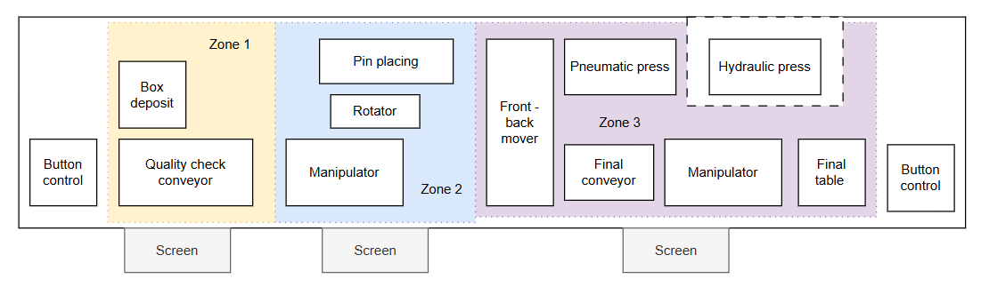
Figure 4.4.1.1 Safety zones division relative to the components` layout

4.4.2 Safety Zone Implementation – Functional Design
To fulfill the safety separation strategy practically and affordably, custom-built upward-sliding doors were implemented in each zone. These doors were preferred because they maximize space efficiency, simplify mechanical design, and minimize the risk of unintended opening. The full door assembly is shown in Figure 4.4.2.1.
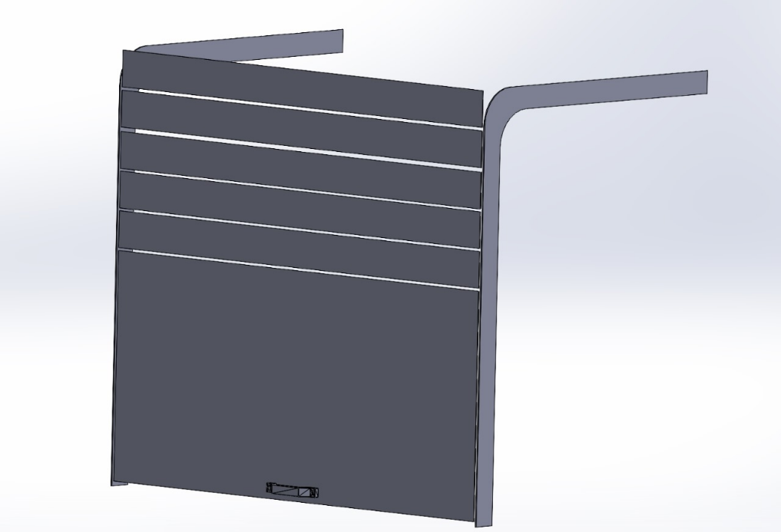
Figure 4.4.2.1 Safety door design
- Curtain railings are adhered to vertical aluminum profiles of the exhibit.
- Transparent acrylic door segments (cut from 3 mm plastic) are manually perforated and affixed to the rails.
- Each door comprises a large bottom segment (for visibility) and several smaller curved panels that follow the track.
- Segments are connected using 3D-printed hinges (Figure 4.4.2.2), chosen for their low production cost and ease of replacement. Hinges are attached with either screws or rivets, depending on the load and positioning. The top segment includes a manual handle for lifting.
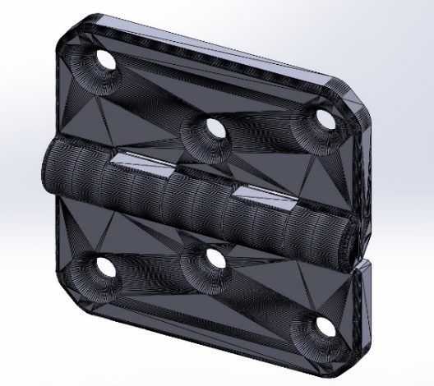
Figure 4.4.2.2 Hinges Connecting Door Segments
All CAD models and STL files are available in the project’s GitHub repository (Appendix B).
To ensure safe operation, non-contact coded safety switches were selected for integration into each door. These switches are compact, tamper-resistant, and comply with ISO 14119. A recommended model is the Pilz PSENcode or Schmersal RSS16, both small enough to fit within the rail structure and available through Dutch suppliers (e.g., Elobau, Conrad, or RS Components NL). Difference between non-contact safety sensors and non-contact safety switches is described in Table 4.4.2.1.
Table 4.4.2.1 Non-contact safety sensors vs. switches
Feature | Non-Contact Safety Sensors | Non-Contact Safety Switches
Functionality | Detects presence without contact | Locks/unlocks access mechanisms
PLC Compatibility | Digital I/O compatible | Integrates with safety PLCs/relays
Compliance | Some meet ISO 13849-1, SIL 3 | Compliant with ISO 14119, SIL 3, PLe
Installation | Easier, less alignment needed | More precise, higher tamper resistance
Cost | €30–150 | €50–200
Selected option: Non-contact safety switch Schmersal RSS16 (IP67, coded actuator, PL e), compact and tamper-proof, available for ~€90/unit.

4.4.3 Fixed Screens and Horizontal Dividers
Goal: To define and reinforce passive safety boundaries between user areas and hazardous machine components where access is not required.
Related Risks: ID 12 (object intrusion), ID 1 (pinching)
In addition to sliding doors, fixed transparent screens were implemented to establish non-interactive boundaries between exhibit zones. These screens are not merely vertical sheets but are structurally integrated into the Mini Factory’s aluminum frame.
Each screen is designed to slide into predefined horizontal slots that already exist in the aluminum beam network above the installation. However, since these slots do not divide the exhibit equally, some screens required curvature or segmentation to match the irregular layout and maintain consistent barrier coverage across zones.
The material used is impact-resistant polycarbonate with a thickness of ≥6 mm, which meets the minimum requirements of ISO 13857 for physical guarding. This material ensures both transparency and durability in a high-traffic, child-focused environment.
Mounting System:
- Screens are manually cut and shaped to follow the contour of the frame.
- Fitted into top beam slots with minimal tolerance to ensure stability.
- 3D-printed guides are used to attach vertical plexiglass panels for side enclosures.
Figures 4.4.3.1 and 4.4.3.2 illustrate the design and spatial relationship of these panels within the exhibit. For ease of assembly and alignment, each screen and bracket are labeled and pre-drilled based on CAD files available in Appendix B.
A vertical panel enclosing the electrical components is also part of the rear structure. This panel includes a cut-out slot at the top that allows it to be removed easily for maintenance. It slides into position along 3D-printed rail guides that are glued to adjacent dividers—an intuitive and tool-free solution ideal for quick staff access.

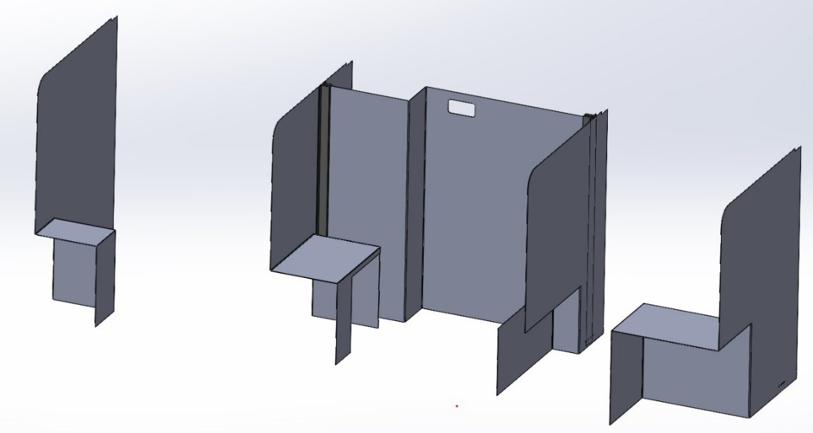
Figure 4.4.3.1 Main exposition dividers and electrical box design
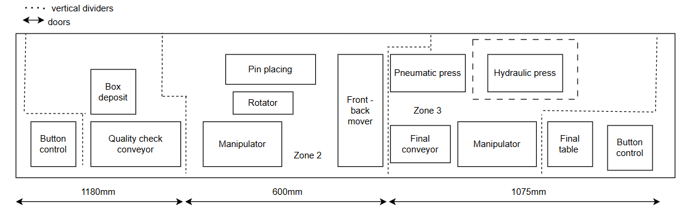
Figure 4.4.3.2 Schematics of zone dividers relatively to exposition`s components

4.4.3 Side Panel Covers for Electrical Box
Goal: To prevent contact with exposed electrical terminals and maintain safe enclosure of critical electronics while supporting educational visibility.
Related Risks: ID 2 (touching open terminals), ID 12 (object intrusion), ID 3 (ungrounded frame)
To complete the enclosure around critical electrical components, plexiglass sheets were installed on the left and right sides of the main electrical box. These panels enhance both safety and aesthetics, aligning with child-friendly design principles agreed upon by the project stakeholders.
Each side panel is inserted into custom mounting slots using 3D-printed adapters, ensuring secure attachment without the need for complex mechanical fixtures. The panels are made of 2 mm thick plexiglass, selected for its transparency and lightness. This allows for easy inspection of internal components while keeping fingers or tools from unintentionally contacting live elements.
To create a more engaging visual environment, decorative acrylic overlays were added to the external face of the panels. These overlays also serve a secondary function by encouraging visual recognition of different zones and components by young users.
All CAD files and adapter models are accessible via the project GitHub (Appendix B).
This side cover system complements the centrally placed vertical back panel of the electrical box, which is intended to provide full transparency of wiring and control systems to engage children with the technical aspect of the exhibit. It is installed directly into the middle section of the rear wall and functions as an educational display as well as a safety barrier. Figures 4.4.3.1, 4.4.3.2 and 4.4.3.3 show design of side covers with used adapters.
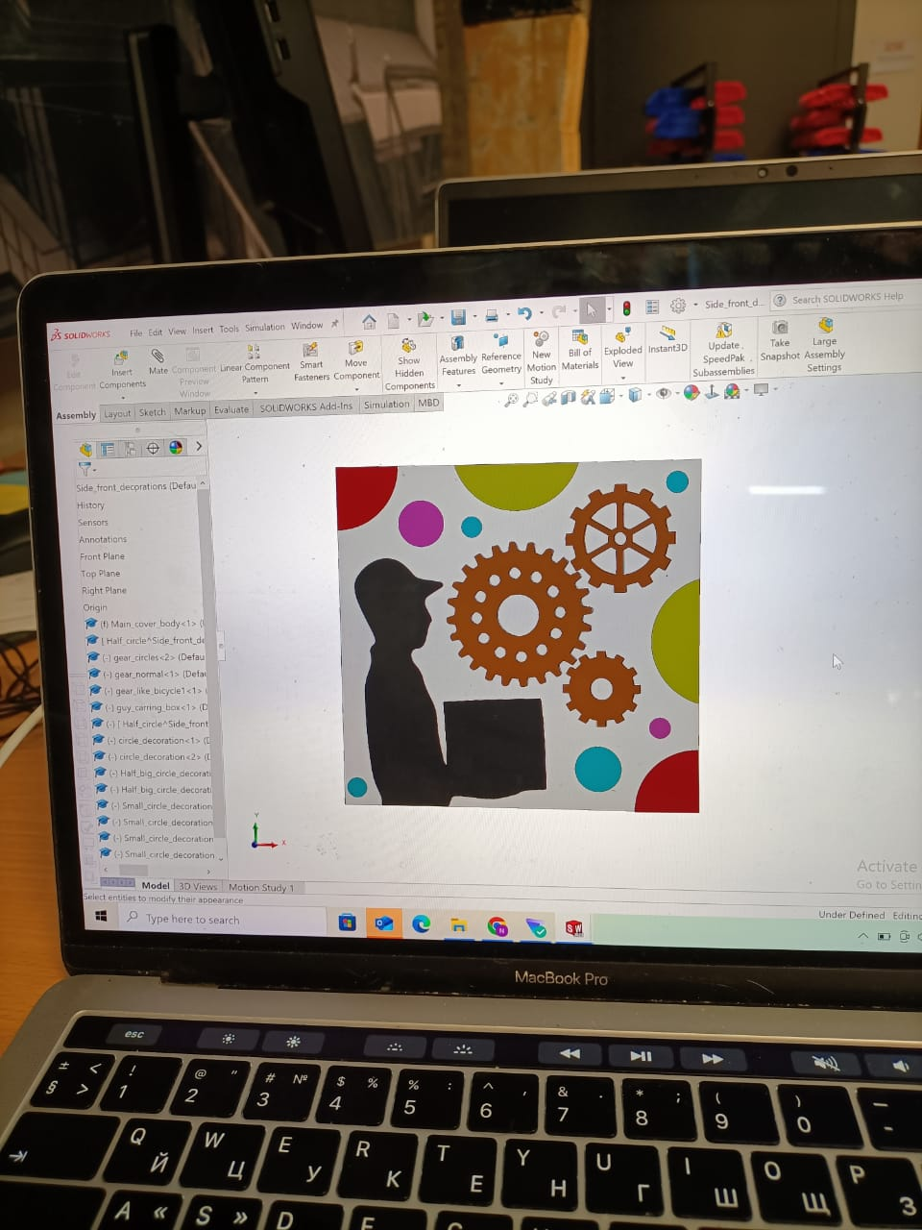
Figure 4.4.3.1 Right side plexiglass sheet

Figure 4.4.3.2 Left side plexiglass sheet
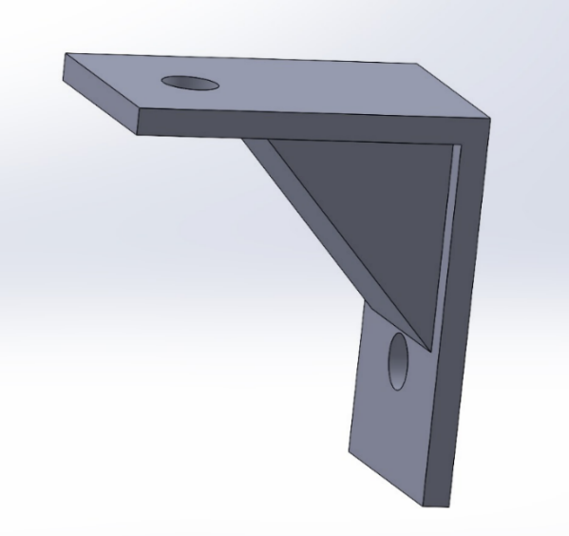
Figure 4.4.3.3 Side Sheet Mounting Adapter

4.4.4 Pneumatics Compressor and Hydraulic Pump Enclosure
Goal: To isolate high-risk components such as the compressor and hydraulic pump, reducing risk of electrical shock, accidental contact, or tampering.
Related Risks: ID 3 (ungrounded frame), ID 14 (tripping over tubes or hitting compressor), ID 1 (pinching), ID 4 (pneumatic hose detachment)
To ensure safety, minimize unauthorized interaction, and maintain visual access for educational purposes, the pneumatic compressor and hydraulic pump—both critical yet potentially hazardous components—are enclosed in a custom-built protective housing. This enclosure is particularly important due to the high pressure, electrical connections, and mechanical movements associated with these systems.
Alternative Designs Considered:
Before selecting the final approach, several enclosure concepts were evaluated:
Full-Metal Cabinet (e.g., sheet metal or industrial enclosure box)
- Pros: Extremely durable, tamper-proof
- Cons: Fully blocks visibility, reduces educational transparency, expensive to customize for irregular layouts
- Reason excluded: Contrary to educational goals and museum visibility needs
Commercial Polycarbonate Enclosure with Locking Frame
- Pros: Off-the-shelf solution, available with certifications
- Cons: Rigid sizing constraints, difficult to fit within exhibit footprint, significantly higher cost
- Reason excluded: Cost-prohibitive and not adaptable to current modular structure
Flexible Curtain Shielding or Mesh Netting
- Pros: Easy access, breathable, lightweight
- Cons: Poor physical protection, non-compliant with ISO guarding standards
- Reason excluded: Offers insufficient protection from mechanical and electrical hazards
Final Design and Rationale:
The final enclosure is a modular structure built using 6 mm thick transparent plexiglass, reinforced with wooden and aluminum elements for structural support. This solution balances cost-efficiency, aesthetic transparency, and safety compliance (aligned with ISO 12100 and ISO 14120 for protective guarding). It also integrates seamlessly into the exhibit layout without consuming additional floor space.
Design Features:
- Transparent Front, Back, Bottom and Side Panels: Enable real-time observation and educational demonstration.
- Rear Access Panel: Hinged and equipped with a padlock latch to restrict unauthorized access while allowing technician maintenance.
- Wooden Base Panel: Provides rigid support and physical separation from the floor.
- Custom 3D-Printed Corner Brackets: Secure the panels into standard 30x30 mm aluminum profiles. Chosen for ease of replacement, modularity, and reduced part costs.
- Assembly Labels and Pre-Drilled Holes: Facilitate fast and accurate installation with minimal tooling required.
- Cable Routing Slot: Integrated in the upper-right of the rear panel to allow safe entry of pneumatic and electrical lines without compromising enclosure integrity.
This configuration provides a robust barrier while still fulfilling the project's educational mission—showcasing internal components in a safe and understandable way. Furthermore, all component models and print files are documented in the project’s [GitHub repository] (Appendix B) to support replication and upgradeability in future deployments.
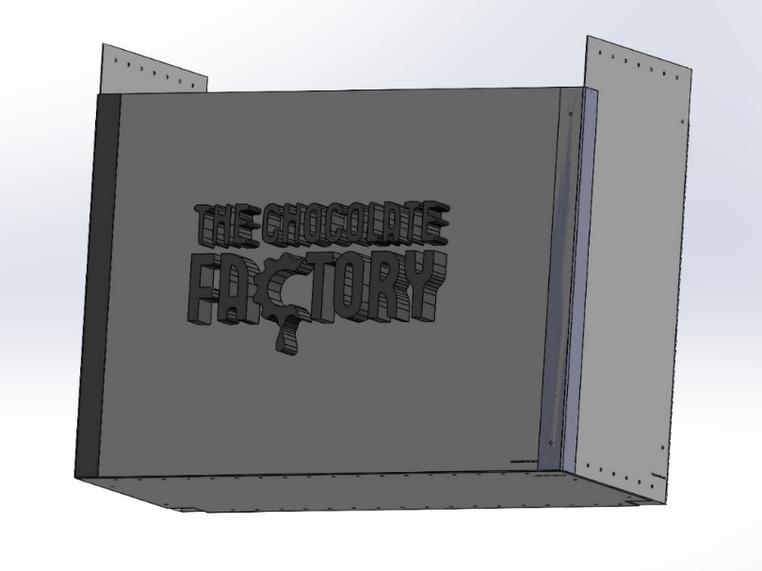
Figure 4.4.4.1 Enclosure design
The enclosure is composed of two side panels (Figure 4.4.4.1), one front panel, and back and bottom sections. Recommended material is 6 mm thick plexiglass. All parts feature assembly labels and pre-drilled holes. Connections are made using 25x15 mm hammer nuts (Moerhammers) and M6 screws. Aesthetics are enhanced by 3D-printed components forming the logo and black cover elements (Figure 4.4.4.2), all glued to the frame.
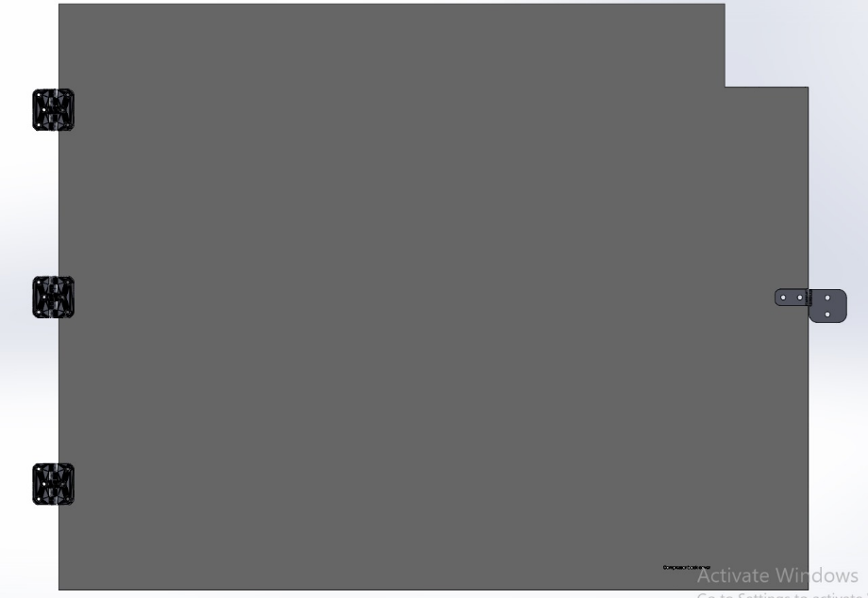
Figure 4.4.4.2 Back door of compressor and hydraulics pump closure design
The rear panel is hinged to the frame using 3D-printed hinges (Figure 4.4.4.3). It features a padlock-ready latch and a cable access slot in the upper-right corner.
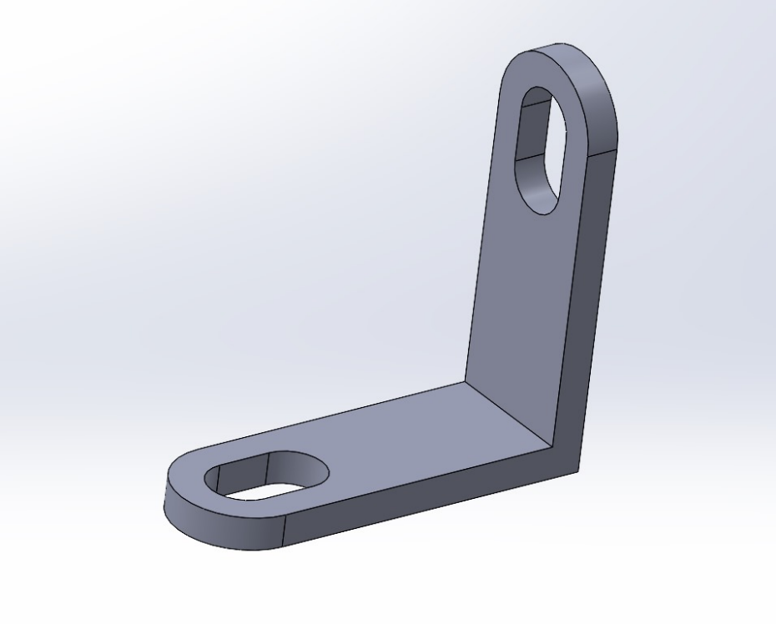
Figure 4.4.4.3 Adapter for a bottom part of compressor and hydraulic pump cover
Due to installation constraints for the bottom panel, a custom adapter is proposed to connect it securely to the side panel. Assembly manual is available under Appendix B.

4.4.5 Rewiring, Cable Management and Total Maintenance
Goal: To eliminate unsafe or unused wiring, improve visual clarity, reduce short-circuit risk, and prepare the system for stable long-term use.
Related Risks: ID 15 (short circuit due to wiring), ID 11 (loose components), ID 2 (touching open terminals)
A critical aspect of the system’s safety and reliability is the organization and protection of electrical wiring. In its current state, the Mini Factory features excessive, unorganized wiring, including unused or outdated electrical components that pose risks of short-circuiting, entanglement, and unintended operation. Given that the system has not been in use for a prolonged period, a comprehensive maintenance and cleanup process is essential. This includes removal of dust, inspection of lubrication points, and replacement of oxidized connectors or degraded insulation.
To address these issues and align with the visual and safety goals of the exhibit, the following design and organizational upgrades are proposed for the electrical section: A centralized aluminum mounting plate will serve as the base for all functional electronics. This enables modular layout, clear component mapping, and simplified diagnostics while still allows children to see all the components of the system.
Implementation Considerations:
While a full electrical rewiring and layout overhaul is the ideal scenario, the current human resource constraints may limit this intervention in the short term. As a result:
- Basic cable management must be prioritized, including bundling, labeling, and rerouting of wires using standard channels and ties.
- All unused components should be identified and permanently disconnected or removed to eliminate ambiguity and reduce risk.
- Visual indicators (e.g., LED status displays) and clearly labeled terminal blocks are recommended for quick fault identification.
These upgrades not only enhance the safety and maintainability of the electrical system but also directly support the user experience, allowing students and museum visitors to visually understand the “brain” of the Mini Factory without compromising operational security. Figure 4.4.5.1 show results of the work done.
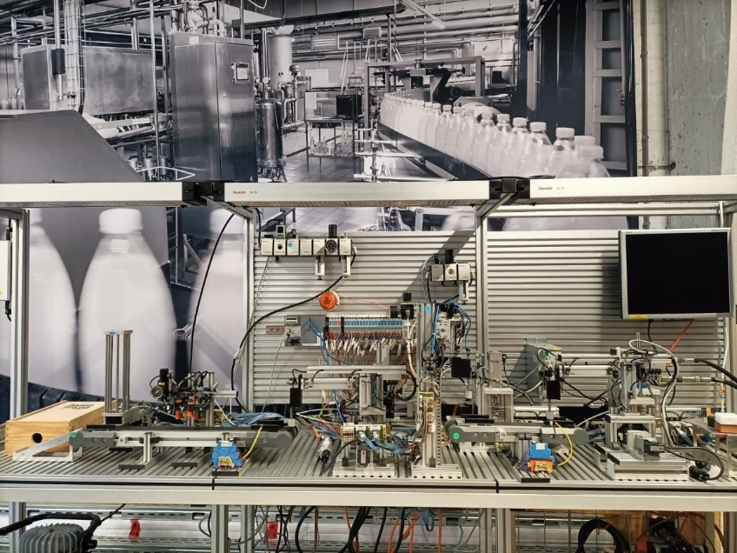
Figure 4.4.5.1 Results of set-up cleaning up

4.4.6 Electrical System Safety Integration
Goal: To ensure system-wide electrical safety through improved documentation, zoning, and preparation for new I/O integration.
Related Risks: ID 15 (short circuit), ID 5 (E-stop system fails), ID 3 (ungrounded frame)
To ensure safe operation, reliable performance, and compliance with international standards such as ISO 13849, IEC 60204-1, and ISO 14119, the electrical system of the Mini Factory is undergoing a comprehensive upgrade. This effort is especially important as the current installation lacks proper documentation, including an official electrical schematic, and features outdated, loosely integrated wiring with no functional zoning. Furthermore, a new I/O system is pending delivery, and therefore some electrical layout decisions will be finalized later in the project.
To address these shortcomings, a new electrical schematic will be developed by a collaborating MBO student from Koning Willem College as part of the rewiring phase. This will ensure all modifications are properly documented, including wiring diagrams, fuse sizing, and relay control logic. All components used will be logged and visualized for future maintenance and handover to Actemium.

4.4.6.1 Current vs. Target Electrical Configuration

Table 4.4.6.1.1 explain overall target for electrical safety implementation. Figure 4.4.6.1.1 show the overall electrical overview of the system and Figure 4.4.6.1.2 shows final target for electrical enhancements.
Table 4.4.6.1.1 Target electrical implementation vs. current system
Aspect | Current System | Target System (Post-Upgrade)
Power Line | Centralized 230V AC | Distributed through MCBs and contactors
Safety Zoning | Not implemented | 3 electrical safety zones (aligned with mechanical zones)
Emergency Shutdown | Basic main switch | Individual zone-based E-Stop logic via safety relays
Fault Isolation | Minimal | RCDs, grounding, and selective MCBs
Documentation | Missing | Schematic in development (MBO student task)
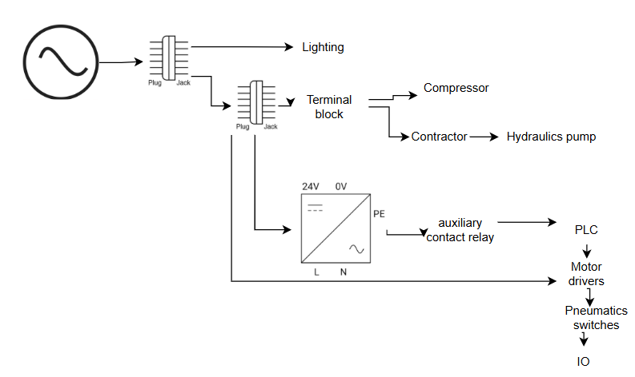
Figure 4.4.6.1.1 Current electrical connections overview
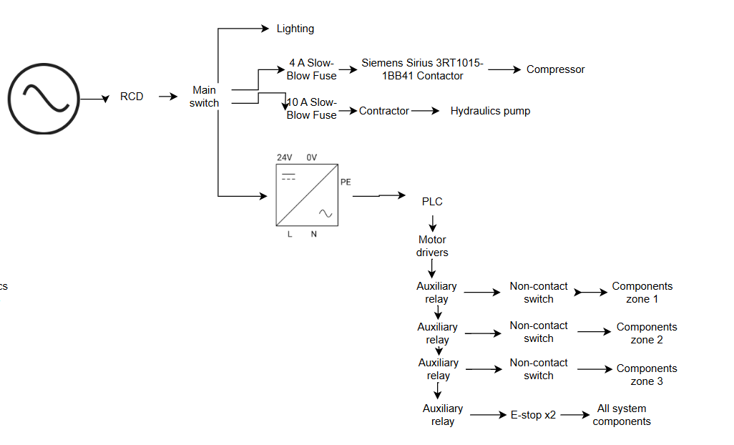
Figure 4.4.6.1.2 Safety enchased electrical design

Documentation of selected components and design references is available in the project’s GitHub repository (Appendix B).

4.4.6.2 Residual Current Device (RCD) & Main Switch Integration
Goal: To detect and interrupt fault currents and isolate the system for safe shutdowns and maintenance.
Related Risks: ID 3 (ungrounded frame), ID 2 (touching open terminals)
RCD Functionality: Detects leakage current (e.g. >30 mA) and disconnects power within milliseconds to prevent electric shock. Combined with proper grounding, it prevents metal components from becoming live in case of insulation failure.
Main Switch Purpose: Allows full isolation of the system for maintenance, emergency intervention, or reconfiguration.
Components Considered:
- RCDs: ABB F202 A-40/0.03, Hager CDA240D, Schneider A9R11240
- Main Switches: ABB OT40F3, Schneider VCF1, Schneider Vario
- Grounding: Phoenix UK 6 PE terminal blocks, 2.5–4 mm² wire, earth busbar
Recommended Setup:
- RCD: ABB F202 A-40/0.03, Type A, 2P, 40A, 30mA
- Main switch: Lockable 3P 40A switch, located near operator access point
- All metal parts must be grounded using star washers and PE links

4.4.6.3 Compressor – Electrical Protection
Goal: To ensure proper circuit protection of the compressor to prevent electrical failure and overheating.
Related Risks: ID 15 (short circuit), ID 3 (ungrounded frame)
The Jun-Air 6-S compressor, rated at 230V, draws approximately 4 A and generates inrush currents on startup. Without proper protection, this may lead to circuit tripping or fire hazards.
Options Considered:
- Industrial fuses (gG 6.3 A): Low cost, but lacks thermal overload protection
- MCB + Thermal Relay: More robust, simplifies diagnostics and manual reset
Recommended Setup:
- Contactor: Siemens Sirius 3RT1015-1BB41 (9 A, 230V coil)
- Protection: 6 A C-curve MCB or slow-blow fuse
- Grounding: All metallic components must be earthed via PE terminal blocks
Important: If the MCB design is chosen then MCB needs to be wired according to the Figure 4.4.6.3.1. It is since normally MCBs are designed for 400V AC, but this system components are powered with 230V AC.
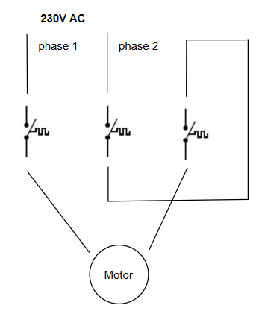
Figure 4.4.6.3.1 MCB wiring diagram

4.4.6.4 Hydraulic Pump – Electrical Protection
Goal: To protect the 400V pump system from overloads and short circuits while ensuring user safety.
Related Risks: ID 15 (short circuit), ID 3 (ungrounded frame)
The hydraulic pump operates at 400V, 4–6 A. It requires isolation and protection against overloads, especially because of its mechanical power and proximity to children.
Options Considered:
- Tripus 0629-3 switch + 10 A gG fuse: Economical, includes thermal trip
- MPCB (e.g. Eaton PKZM0-6.3): Easier PLC integration and precise reset handling
Recommended Setup:
- Contactor: Eaton DIL R40 (already installed)
- Protection: 10 A Type C MCB or 10 A slow-blow fuse
- Optional: Thermal relay ZB12-6.3 (if MPCB not installed)
Important: if MCB is used, then refer to the Figure 4.4.6.3.1 for electrical wiring diagram

4.4.6.5 Emergency Stop & Zone Interlock Safety Integration
Goal: To implement a dual-layer safety system combining local interlocked access prevention with global emergency shutdown, ensuring safe interaction for children in a public museum environment.
Related Risks:
- ID 5 (E-stop fails)
- ID 1 (pinching)
- ID 8 (overextension)
- ID 12 (object intrusion into moving parts)
To comply with ISO 13849 and support safe, zone-based operation, the MiniFactory is divided into three independent electrical safety zones. Each zone includes:
- A non-contact safety switch (interlocked door) to prevent access during operation
- A dedicated safety relay to isolate motion and pneumatics locally if that door is opened
In addition, a global Emergency Stop system is implemented using:
- Two E-stop buttons, placed at opposite ends of the exhibit
- One shared safety relay, cutting power to all zones in critical situations
Table 4.4.6.5.1 show complete overview of safety zoning.
Table 4.4.6.5.1 Updated Safety Zoning & Logic
Zone | Controlled Devices | Interlock Safety Switch | Local Relay | Global E-Stop Coverage
Zone 1 | Pneumatics, motors | Schmersal AZM40 or equiv. | Yes | Yes
Zone 2 | Same | Schmersal AZM40 or equiv. | Yes | Yes
Zone 3 | Same | Schmersal AZM40 or equiv. | Yes | Yes
Exhibit Ends | — | — | Main system relay | E-Stop buttons ×2
Components Selected:
- E-Stop Buttons: Red mushroom-type, Normally Closed (NC), located at each end of the exhibit
- 🔒 Non-contact Safety Switches: Schmersal AZM40 (coded actuator, IP67, PL e compliant)
- ⚡ Safety Relays:
  - 3 × Pilz PNOZ X2.1 (one per zone)
  - 1 × Pilz PNOZ X3 or ctrlX SAFEX for global E-stop chain
- 🔌 Contactors: Finder 38.51 (24VDC coil) or equivalent for actuator isolation
- 💡 Logic Flow:
  - Zone Interlocks → Local relay disables motion in that zone
  - E-stop Buttons → Global relay disables all relays and actuators
  - PLC remains powered during E-stop for diagnostics and logging
This dual-safety scheme ensures that:
- Each zone can be entered safely after local power-down via interlock
- Emergency stops instantly cut all power across zones, without delay
- Children and museum staff can act quickly and safely in any situation

4.4.6.6 Covers for Reachable Electronic Components
Goal: To enclose exposed or accessible electronics (buttons, sensors) to prevent accidental contact or tampering by users.
Related Risks: ID 2 (touching terminals), ID 12 (object intrusion), ID 6 (joystick/button jam)
To complete the system’s protective structure, all exposed buttons, sensors, and terminals will be housed in custom 3D-printed covers. These will prevent accidental access while preserving visibility.
Cover Types to be Fabricated:
- 2 × Button covers
- 2 × Sensor covers
- 1 × Test stand cover
- 2 × Motor covers
- 2 × Press electronics covers
These covers are lightweight, removable, and cost-effective. All design files and STL models are available in the project GitHub repository (Appendix B).

4.4.8 Software-Based Motion Limits
Goal: To prevent overextension of moving actuators by enforcing safe boundaries through software logic.
Related Risks: ID 8 (overextension), ID 9 (software crash)
To prevent mechanical overtravel and reduce the risk of user injury or equipment damage, software-enforced motion limits have been implemented for all actuated components, particularly the two main manipulators and the press system.
Each actuator is assigned a predefined operational boundary based on the physical limits identified during risk assessment and mechanical integration. These constraints are continuously monitored during runtime through encoder feedback or control logic bounds. If a motion command attempts to exceed these predefined thresholds, the system:
- Interrupts the operation immediately
- Triggers an emergency stop state
- Prevents any further commands until the component is reset within a safe range
This strategy not only satisfies core system safety requirements (SSR.6, TSR.1) but also offers a programmable safeguard that complements physical barriers and interlocks.
Software-based limits are especially useful in educational environments where inexperienced users may unknowingly input unsafe commands. Unlike hard end-stops, software limits are easily configurable and scalable as the system evolves, making them an essential part of both prototyping and future-proofing the installation.
Additional software safety mechanisms—such as user access levels, interface flow, and instructional overlays—are discussed in Chapter 6: Software Design. Precise information on software limits will be available after rewiring of existing system.

Full Component & Manufacturing Table
To implement the safety redesign of the Bosch Rexroth Mini Factory, a detailed budget estimate is required. This budget includes costs associated with mechanical redesigns, electrical upgrades, safety components, software modifications. Table 4.5.1 and Table 4.5.2 list all the proposed components in this design brief. Components listed in black are mandatory ones, while components in blue are optional but still recommended.

Table 4.5.1 Components list with recommended suppliers for safety implementation
Component | Purpose | Qty | Approx. Price (each) | Supplier
ABB F202 A-40/0.03 RCD | Residual current protection | 1 | €110.85 | Elettronew
ABB OT40F3 Main Switch (Lockable) | Main system isolation | 1 | €41.60 | Farnell
Contactor for Compressor (Siemens Sirius 3RT1015-1BB41) | Start/stop compressor | 1 | €35–50 | Conrad / Farnell
MCB 6A Type C for Compressor | Overcurrent protection | 1 | €7–10 | Schneider / ABB / Hager
MCB 10A Type C for Hydraulic Pump | Overcurrent protection | 1 | €7–10 | Schneider / ABB
Thermal Overload Relay | Motor protection if no MPCB | 1 | €30–45 | Eaton (ZB12-6.3)
Emergency Stop Buttons (NC) | Safety shutdown | 3 | €5–15 each | Schneider, IDEC, EAO
Safety Relay (Pilz PNOZ X2.1 or ctrlX SAFEX) | Process monitoring and E-stop logic | 4 | €120–300 each | Pilz / Bosch Rexroth
3D Printed Safety Covers (PLA) | Custom machine safety parts | ~10-15 items | €18.99/kg (PLA) | Filamentz.nl / Reprapworld
2mm Polycarbonate Sheet (1x1 m) | Interlocked safety windows | 5 | €32.40 each | Kunststof Forte BV
2mm Acrylic Sheet (1x1 m) | Covers and decorative parts | 2 | €16.02 each | SIA Ultraplast EU
Schmersal AZM40 | Interlocked doors safety | 3 | €45-60 | Schmersal
IDEM PRH-12-SS | Interlocked doors safety (either this component or previous one) | 3 | €75-90
Curtain railing | Railing for interlocked doors | 6 | €62,80 | AliExpress
Moerhammers and M6 screws | Assembly |  | €100
Total |  |  | €1312-2091

Table 4.5.2 Manufacturing list with recommended suppliers

Material / Workpiece | Purpose | Qty | Process Required | Notes
2mm Polycarbonate Sheets | Safety doors, windows | 5 x 1×1 m | Laser cutting + heat bending | Use for moving parts, doors
Laser-Cut Acrylic Sheets | Panels, mounting plates | 12 (custom designs) | Laser cutting | Exact dimensions needed
2mm Acrylic Sheets | Side covers | 2 x 1×1 m | Laser cutting | Transparent or opaque
Colored Acrylic Sheets | Branding or visual safety areas | 2 x 1×1 m | Laser cutting | e.g. red, yellow, blue

Maintenance Plan
To ensure the safe, reliable, and long-term operation of the Mini Factory installation—especially in a public, high-usage educational setting—a structured and preventive maintenance plan is critical. This plan minimizes downtime, prevents safety degradation, and extends the system's operational life, particularly in light of its exposure to repeated interaction by children and the sensitive nature of its pneumatic, hydraulic, and electronic components.
Regular maintenance is not only a best practice but also a compliance requirement under standards such as ISO 12100, ISO 13849, and IEC 60204-1, which mandate that safety-related parts of control systems are inspected, tested, and validated over time.
How the Maintenance Schedule Was Developed
The maintenance schedule was developed by analyzing a combination of manufacturer datasheets, risk assessment outcomes, and relevant international safety standards, particularly:
- ISO 12100: General principles for risk reduction
- ISO 13849-1: Safety-related parts of control systems
- IEC 60204-1: Electrical equipment of machines
Manufacturer guidelines for components such as the Jun-Air compressor, Bosch Rexroth pneumatics, and Eaton hydraulic pumps.
- To ensure that the safety and reliability of the Mini Factory are maintained throughout its public use lifecycle, each system component was cross-referenced against:
- Operating environment and exposure (e.g., frequent interaction by children, indoor humidity, long idle periods)
- Expected mechanical wear or failure mode (e.g., oil degradation, tubing leaks, cable stress)
- Recommended maintenance intervals from datasheets
- Design decisions specific to this project (e.g., 3D printed parts that are less durable than metal alternatives)
For instance:
- The compressor datasheet recommends draining moisture weekly and replacing filters bi-annually under moderate duty cycles.
- The pneumatics system includes cylinders and valves whose seals may degrade over time or leak without lubrication—hence the bi-weekly inspection cycle.
- Hydraulic systems require periodic oil checks and annual replacement, as per industrial standard practice (often listed in technical manuals).
- Safety devices like E-Stops and interlocks, classified under Category 3 or 4 per ISO 13849, must be validated frequently, especially when operated in an uncontrolled public setting.
- PLC modules and interface screens, while electronically reliable, are prone to wiring fatigue and physical wear over time, particularly when unshielded or mounted in movable exhibits.
The final plan was then adapted to the project context: limited technical staff, museum operating hours, and mixed-use educational objectives. As such, the plan balances preventive maintenance with ease of scheduling and task distribution, making it feasible for both professional technicians and trained museum staff to contribute to the system's longevity and safe use. Table 4.6.1 explains parties involved in the maintenance and Table 4.6.2 describes maintenance schedule

Table 4.6.1 Roles and Responsibilities
Role | Responsibility
Maintenance Technician | Performs inspections, lubrication, basic repairs
Safety Officer | Verifies safety device functionality and logs inspections
Electronics/PLC Technician | Manages control system integrity, backups
IT Staff | Ensures UI/UX devices are functional and up-to-date
Museum Host / Staff | Performs daily checks and surface cleaning
Supervisor / Project Lead | Reviews logs, validates updates, oversees audit readiness

Table 4.6.2 Maintenance plan overview
Component / System | Inspection Frequency | Maintenance Task | Responsible Person / Role | Notes
PLC & I/O Modules | Monthly | Check wiring integrity, module status LEDs, ensure communication | Technical staff / Electronics Tech | Backup PLC program should be checked annually
Compressor Unit | Weekly (visual) / Monthly (functional) | Inspect air leaks, pressure, temperature; drain tank | Maintenance Technician | Replace air filter every 6 months
Pneumatic System | Bi-weekly | Check tubing for leaks, inspect cylinders and valves | Maintenance Technician | Lubricate every 6 months
Hydraulic Pump & Press | Weekly (visual) / Monthly (functional) | Check fluid levels, inspect press movement and safety covers | Certified Technician | Change oil annually; check pressure quarterly
Safety Devices | Weekly | Test E-stops and interlocks; check wiring | Safety Officer / Technician | Record tests; replace faulty devices immediately
Transparent Covers / Screens | Monthly | Clean and inspect for damage | Maintenance Team | Replace damaged screens immediately
Structural Frame | Monthly | Check for loose bolts, wear, alignment | Maintenance Team | Tighten connections; check for deformation
Wiring & Cable Management | Monthly | Inspect wires/connectors; ensure proper routing | Electrical Technician | Replace any damaged cables
User Interface Screens | Weekly | Check responsiveness and wear | IT / Maintenance Team | Replace scratched/damaged screens
3D Printed Covers & Mounts | Quarterly | Inspect for cracks/deformations | Maintenance Team | Reprint and replace as needed
General Cleaning | Weekly | Wipe exposed surfaces and user areas | Museum staff / Host | Prevents dust accumulation and wear

Appendix H has maintenance forms and report`s frameworks.

Conclusion Chapter 4
The system was successfully re-engineered to meet safety requirements for public, child-focused environments. Through a combination of physical barriers (interlocked doors, fixed screens), electrical safeguards (RCDs, grounding, E-stops), and software-based protections (motion limits, admin access), the MiniFactory now aligns with key mechanical, electrical, and software safety standards. Each mitigation action was mapped to a design feature, ensuring transparency and accountability. The improvements are both functional and educational, allowing visitors to safely explore industrial automation concepts. Safety report was developed together with assembly and maintenance documentation; components are waiting to be purchased and deployed.

Chapter 4: Improvements to the existing system
The Bosch Rexroth Mini Factory was originally developed as an industrial demonstration tool to train future engineers. However, its design was never tailored for children—its interface, components, and layout lacked accessibility, engagement, and educational clarity. Beyond addressing safety, this project aims to enhance the system’s functionality, aesthetics, and educational value for young users, particularly in the context of The Chocolate Factory’s museum environment.
This chapter presents hardware improvements made during the internship and outlines new components under development. Each enhancement is justified based on user requirements and system requirements such as:
- SSR.1 – Create a background story for better child engagement
- MSR.2 – Motivate children through age-appropriate hardware
- MSR.3 – Provide child-friendly control elements
- MSR.6 – Ensure modularity for future expansion
- SSR.2 – Support interaction across multiple operational modes
All CAD models and STL files referenced in this chapter are available in the project GitHub (Appendix B).

User Experience: The Chocolate Packaging Concept
To make the system intuitive and goal-oriented for children, the theme of chocolate packaging was adopted. This decision was made in consultation with museum stakeholders (see Appendix B for agenda and minutes from meetings) and aligns well with the location context. Instead of abstract industrial processes, children now engage with a recognizable and enjoyable mission—to pack a piece of chocolate.
To bring this idea to life, the following elements are being developed during the internship:
Chocolate Deposit – Represents the initial stage of the process, where a chocolate piece is symbolically “received.”
- Box Design & Tower – Customized containers that simulate packaging and storage of chocolate.
- Box Holders – Intuitive, accessible racks for handling and organizing chocolate boxes.
- Visual Background – Designed storytelling elements that convey the purpose and steps of production.
These additions transform the machine into a narrative-driven, multi-sensory experience, increasing both usability and emotional engagement for users aged 8+.

Box Design
To ensure compatibility with the existing actuators and mechanical layout, the original Bosch Rexroth box design was used as a baseline. The redesigned box meets the following criteria:
- Compatible with existing pneumatic pushers and suction arms. Because any filles were given about Bosch box design, trial and error approach was chosen (MSR.4)
- Printable on-site with PLA using standard Chocolate Factory 3D printers
- Sufficient weight and surface finish to interact reliably with sensors and actuators
Table 5.2.1 Test results of box testing
ID | Test Description | Pass/Not Pass | Comments
1 | 3D printed 50% infill |  | Too light to activate button actuator in Box intake
2 | 3D printed 100% infill |  | Passed drop and throwing tests with good durability
3 | Small letters engraving on top |  | Suction works well even with full surface text
4 | Big letters engraving on top |  | Suction ineffective due to large engravings
5 | Small letters on the side
6 | Big letters on side |  | Pneumatics unable to lift due to surface area
7 | Hole on the side (original design) |  | Fails to trigger actuator in Box intake
Several prototypes were iteratively printed and tested (Table 5.2.1). Key test results included:
- 100% infill proved durable and heavy enough to trigger sensors
- Side engravings affected pneumatic gripping ability; large text failed; small text succeeded
- Hole placements were revised to align with existing detection systems
The final box design strikes a balance between usability, aesthetics, and printability. Colors can be varied to represent different chocolate types (dark, milk, white), reinforcing the educational theme. Picture of final design can be seen on Figure 5.2.1. Design was developed by MBO student and validated by intern student.
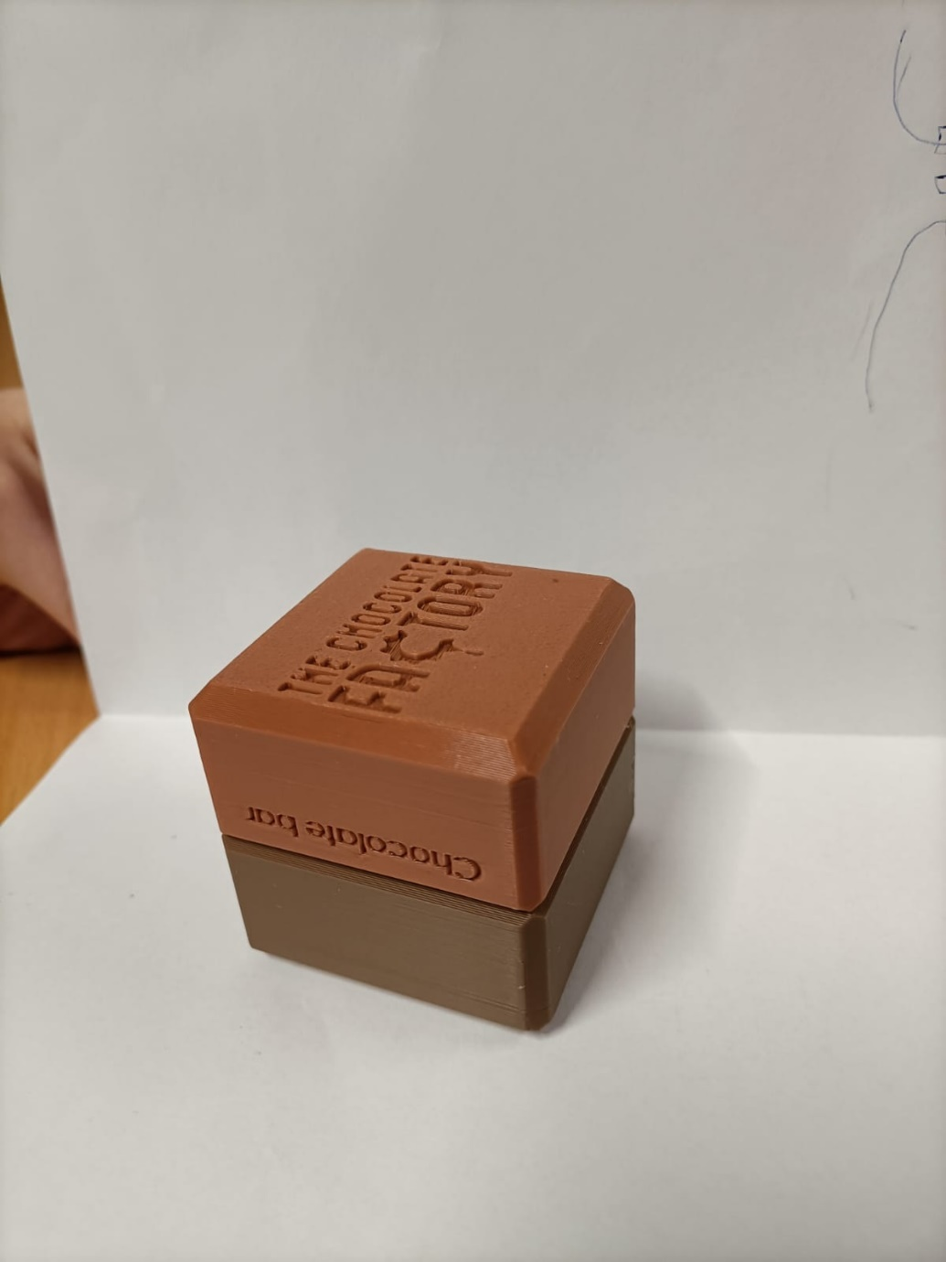
Figure 5.2.1 Final design of printable box

Box Holders
To manage printed boxes efficiently, dedicated box holders were designed with the following constraints:
- Child-friendly access (MSR.3)
- Mounted onto the existing aluminum profile structure (MSR.6)
- Modular and printable without special tooling (SSR.5)
Three design concepts were considered:
- Just Box – Simple but bulky and unattractive
- Exposition (place all boxes on plate like on exposition) – Informative but space-consuming and inflexible
- Screw Box (Figure 5.3.1) – Compact, modular, and visually clean
The “Screw Box” design was selected for its ease of production, structural compatibility, and clean aesthetics. Its modularity ensures that it can be replicated or adjusted as future use cases evolve. Figure 5.3.1 show the final result of the part. Also incorporates naming plates that can be easily changed, so holders can be separately produced from naming plates.
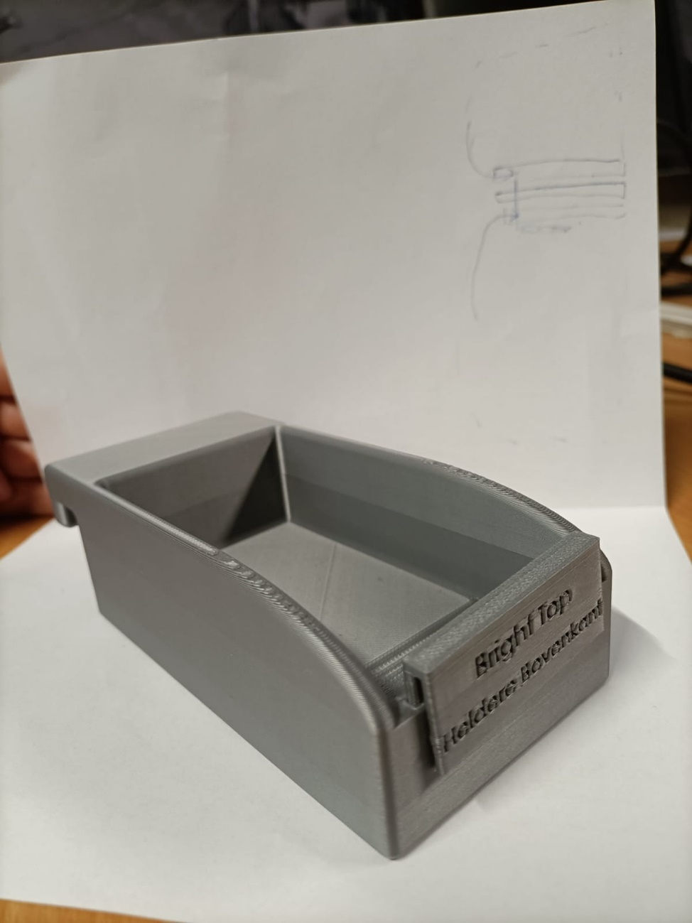
Figure 5.3.1 Prototype of box holder

Components Under Development
In addition to the hardware elements already developed and tested, two key components of the MiniFactory system are currently under active development during this internship (Table 5.4.1). These elements are essential to completing the transformation of the MiniFactory into an interactive, story-driven educational tool suitable for children aged 8–18. All of them directly support the chocolate packaging narrative and fulfil specific system requirements related to modularity, user engagement, and visual storytelling.

Table 5.4.1 Overview of In-Development Components
Component | Purpose | Linked Requirements
Chocolate Deposit | Introduces the symbolic start of the packaging process | SSR.1, MSR.2, MSR.6
Box Tower Improvements | Enables reliable storage and feeding of boxes | MSR.4, MSR.6, MSR.7

Conclusion for Chapter 5
Hardware components are being redesigned to support a more narrative-driven and interactive experience. The chocolate packaging concept transformed abstract automation processes into an engaging story for children. Components such as custom box designs, box holders, chocolate deposit, and visual backgrounds were either developed or scoped for future completion. All designs followed modular, print-at-site strategies to reduce cost and support future iterations. This chapter highlights how narrative framing and user-centered prototyping improved both usability and educational value.

Chapter 6: Software design
To enable meaningful interaction between the system and users and to support the creation of an engaging educational experience, the system software must be significantly updated. This section outlines the core software components of the project, detailing all modifications and enhancements made. All software developments follow a structured V-model approach up to module testing. Final integration and validation are addressed in Chapter 6.

Customer and User Research
To ensure the Bosch Rexroth Mini Factory is both educationally effective and intuitively engaging for children aged 8 to 18, a comprehensive user research strategy was developed. This included defining user personas, creating phased user stories, and mapping system features to age-specific needs and roles such as students, teachers, parents, museum staff, and system administrators.
Designing educational software for children and adolescents aged 8 to 18 requires an understanding of their cognitive, emotional, and technological development stages. According to the OECD’s report “21st-Century Children” (OECD, 2019), this age group:
- Develops progressively stronger problem-solving and logic skills from ages 8 to 12, making visual programming languages like Scratch ideal entry points.
- Transitions into abstract thinking around ages 13–15, enabling the effective introduction of text-based programming such as JavaScript.
- Values autonomy, exploration, and social recognition, which supports the inclusion of unlockable levels, self-directed tutorials, and gamified rewards.
- Requires clear visual structure, low frustration tolerance in younger children, and engaging narrative framing for attention retention (especially among 8–12-year-olds).
The user story board (Appendix I), visualized in Figure 6.1.1 (developed in Miro), segments the expectations into three progressive software releases. This phased approach helps identify minimum viable features for early deployment (Release 1) while structuring a long-term development plan (Releases 2 and 3) for future improvements and scaling. It directly supports requirements traceability (URs, MSRs, SSRs, and ESRs).
Each story follows a structured format:
As a [user type], I want [feature] so that [value/benefit].
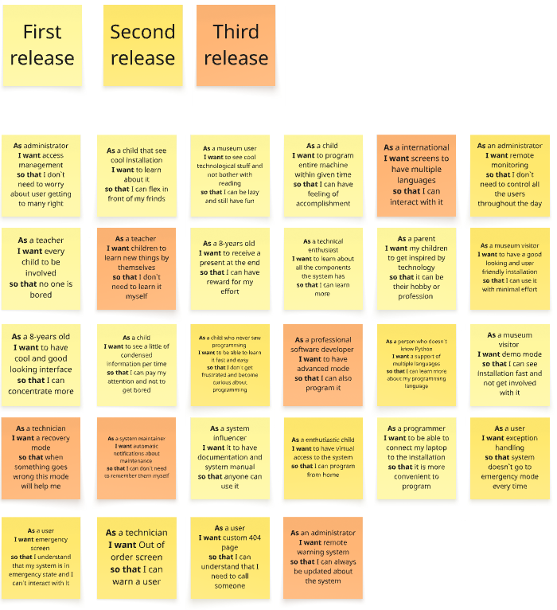
Figure 6.1.1 User story

Software System Architecture by Operational Mode
To meet the diverse educational and technical requirements of the MiniFactory project, the software has been designed around three key operational modes: Demo, Leisure, and Learning. These modes directly address SSR.2 and are aligned with multiple user requirements, particularly UR3 (interactive controls), UR4 (Scratch-based programming), UR6 (multiple modes), and UR11 (step-by-step tutorials).
All modes are implemented using the ctrlX CORE platform developed by Bosch Rexroth and displayed on 3 screens (for detailed information see MBO student report in Related documents). This platform supports web-based control, block-based programming, real-time motion control, and extensibility through modular apps. The selected implementation focuses on simplicity, compatibility with the museum's goals, and the practical constraints of the project timeframe.
Since final deployment falls outside the internship scope (TSR.4), this section outlines the validated software architecture and what will be implemented during this project.

6.2.1 Demo Mode
Purpose: Automatically showcase the capabilities of the MiniFactory in a continuous loop, intended for exhibition or idle periods.
Architecture Strategy: Leverages the existing legacy program, originally developed to demonstrate Bosch Rexroth’s automation technologies. No changes will be made to this program during this project.
Reasoning: This decision was strongly proposed by Bosch Rexroth, one of the key stakeholders (see Appendix B for agenda and minutes from meetings), and agreed upon by both Actemium and The Chocolate Factory. Maintaining the original code ensures brand consistency, reliability, and avoids introducing new risks to a proven system.
Demo mode remains unchanged and runs the pre-programmed sequence as-is, activated via a simple button press (Figure 6.2.1.1). The program consists of preprogrammed hardware modules provided by Christiani (see Appendix B for manuals) and Bosch Rexroth integration of them (documentation may be requested from Bosch under specific use case due company confidentiality).
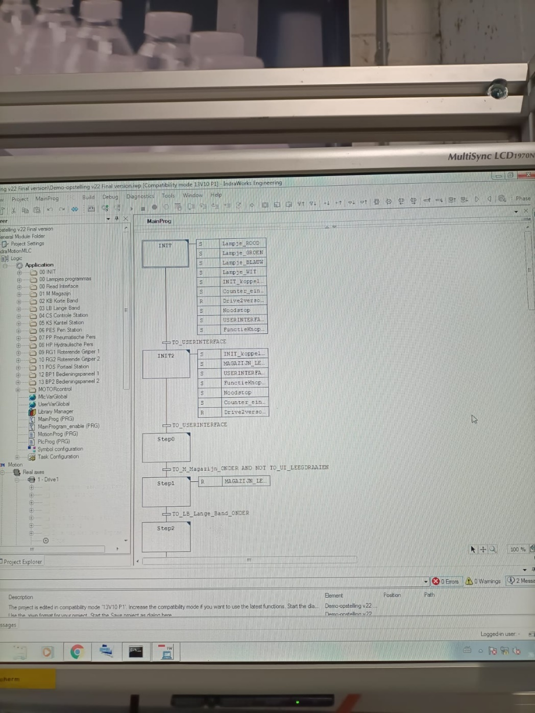
Figure 6.2.1.1 Screenshot from demo mode (existing program)

6.2.2 Leisure Mode
Purpose: Provide an engaging, guided tour of the MiniFactory’s physical components through visual storytelling and synchronized motion.
How It Works:
- Upon pressing a start button, the system pushes a chocolate box to the first mechanical stop.
- The WebIQ screen simultaneously displays a description of the corresponding component (e.g., actuator, sensor).
- The user presses “Next” to move the box to the next stop, triggering the next stage of the educational sequence.
Architecture:
- WebIQ HMI App: For step-by-step explanations and user interface design.
- ctrlX PLC App: Manages axis movement and synchronization with UI steps.
Reasoning for App Selection:
- Requires only one additional app (WebIQ) plus the already needed PLC app – making it cost-efficient and lightweight.
- WebIQ offers seamless integration with the PLC logic, reducing overhead.
- Bosch Rexroth provides rich documentation, video tutorials, and templates for WebIQ and PLC integration, minimizing development effort and easing the learning curve.
Table 6.2.2.1 describes all considered options for leisure mode implementation.

Table 6.2.2.1 Alternative Options Considered for leisure mode
Option | Architecture | Pros | Cons
Node-RED + UI Dashboard | Node-RED logic with dashboard UI | Open source, modular, browser-based UI | Steeper learning curve, less Bosch-specific support, separate programming from PLC
Custom React/Vue App | External web app + REST API or OPC-UA link to PLC | Total flexibility in UI/UX, scalable | High development time, requires middleware, not plug-and-play with ctrlX CORE
ctrlX HMI App | Native ctrlX HMI Snap (less used) | Tight OS integration | Limited customization, less community documentation than WebIQ
Why It’s Being Developed Now:
Originally, this “educational path” was planned to be developed by a collaborating MBO student. Since that delivery did not occur, it has been incorporated into the current project scope. Development of this component will take place during this internship timeframe.

6.2.3 Learning Mode
Purpose: Allow users (primarily children aged 8–18) to program and control the MiniFactory using block-based and text-based coding tools.
Features to Be Developed in This Project:
- Step-by-step tutorials guiding users through programming basics.
- A responsive and child-friendly interface for block programming and axis interaction.
- Integration of Blockly, Python, and JavaScript with access to the real MiniFactory or its simulation.
Architecture:
- ctrlX IDE App: Central programming environment supporting Blockly, Python, and JavaScript.
- ctrlX Motion App: Handles axis and kinematic configuration, provides real-time control interface.
- 3D Viewer App: Enables simulation of movements for virtual testing and remote programming experience.
Why This Approach Was Selected:
- The IDE app natively supports multiple languages (Blockly, Python, JS) and even auto-translates between them, simplifying learning and offering scalability for different user levels.
- Motion App provides intuitive setup for kinematics and axis control, and will streamline connection to the physical MiniFactory once hardware is available.
- Since the actual ctrlX CORE unit has not been purchased yet, the 3D Viewer provides the only way to simulate, visualize, and validate control logic at this stage – making it essential to interface development.
Table 6.2.3.1 describes all considered options for learning mode implementation.

Table 6.2.3.1 Alternative Options Considered for learning mode
Option | Architecture | Pros | Cons
1. Node-RED + Blockly Integration | Blockly front-end with Node-RED backend linked to PLC | Open-source, can simulate logic | Requires middleware (e.g. MQTT, OPC-UA), limited 3D simulation, indirect hardware connection
2. Snap4Arduino / mBlock | Third-party block coding platforms for robotics | Familiar in education, easy to use | Not compatible with ctrlX architecture, cannot connect to factory actuators directly
3. Python Jupyter Notebook + Web3D | Educational Python notebook linked with WebGL simulation | Highly customizable, technical depth | Inaccessible to young users, no native PLC or motion integration, complex for museum staff
Educational Value:
This configuration directly supports:
- SSR.4 (Block + JS programming)
- SSR.7 (Real-time feedback)
- UR11 (Step-by-step tutorials)
- UR13 (Gamification via simulation and feedback)
A full explanation of app installation, axis configuration, programming setup, and simulation via the 3D Viewer can be found in the Software Installation Guide (Appendix B). This guide is also intended to help other developers replicate or extend this system. Delays in development are expected due to the collaboration with Christiani company for implementation of their educational set ups into 3D Viewer app.

6.2.4 Admin Access and System Status Interfaces
To ensure safe and controlled operation of the MiniFactory—especially in an educational setting with frequent user turnover and potential misuse—a dedicated Admin Access system has been implemented as part of the web interface.

Purpose and Role of Admin Access
Admin access acts as the central point of control and diagnostics for the installation. It provides museum staff, developers, and maintenance personnel with privileged capabilities that are not available to standard users, such as:
- Placing the system into maintenance or error mode.
- Accessing internal logs or system status.
- Restarting or reinitializing system components.
- Navigating to diagnostics or configuration pages.
- Reviewing or clearing stored user programs (Learning Mode).
This functionality is essential to prevent unauthorized access to sensitive functions and to enable quick and safe resolution of errors or abnormal conditions.

Admin Access Implementation Strategy
The admin interface is built as an extension of the web-based user interface already selected for the MiniFactory system. This approach offers several advantages:
- No external devices required (e.g., no separate touchscreen logic or HDMI interface).
- Easily accessible from any connected device on the same network (laptop, tablet).
- Fully integrable with existing ctrlX PLC logic, allowing for tight coordination between UI state and physical system state.
- Future-proof: expandable to include login tracking, audit logs, or advanced diagnostics.

Access Control Mechanism
Admin access is gated via a password-protected login screen (Figure 6.2.4.1), ensuring that only authorized staff can enter maintenance or administrative modes. Credentials will be hardcoded during development but can be easily reconfigured in the final version.
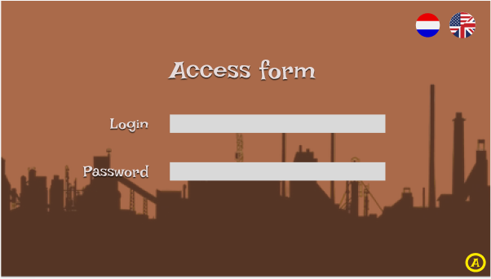
Figure 6.2.4.1 Admin login page

Additional Pages and Features
In addition to the main user pages, several special-purpose pages have been designed in the web interface to handle system exceptions, maintenance, and control tasks (Table 6.2.4.1).
Table 6.2.4.1 Additional pages for admin access
Page | Function
Admin Page | Main control panel for staff and developers
Out of Order Page | Automatically displayed in case of a system failure or manual override
Error Page | Displays critical fault information (e.g., actuator not responding, sensor failure)
Loading Page | Intermediate screen to mask transitions or background logic execution
Admin UI Extensions | Possibility to add pages for logs, manual actuation tests, or mode overrides
These pages are also helpful during system testing and development phases, offering direct interaction points for debugging and hardware testing without needing an external IDE or engineering environment.

Design and Availability
All page layouts were prototyped in Figma (Appendix J) to ensure intuitive navigation and visual consistency. These designs reflect Bosch’s user interface guidelines while incorporating feedback from Actemium and The Chocolate Factory to align with the museum’s visual and accessibility standards. The final HTML versions of these pages will be included in the GitHub repository (Appendix B).
This modular page structure ensures that future updates—such as new operating modes or hardware components—can be incorporated without rebuilding the entire system.

Hardware and Software Architecture Budgeting
The software platform for this project was selected in close collaboration with an MBO student from Koning Willem College. Information was taken from report of MBO student (Vos, P. (2025, March 5). Proeve van bekwaamheid: Moderniseren van de Bosch Rexroth Trainer – Puc). A comparative study was conducted between Bosch Rexroth’s XM42 MLC and the ctrlX CORE controller.
Key reasons for choosing ctrlX CORE:
- Modern web-based interface accessible via browser (more intuitive for children).
- Native support for educational tools like Blockly and Python.
- Open architecture allows easier future expansion and integration.
- Lower cost compared to industrial MLC (see budget breakdown).
- Full ecosystem available with apps for PLC logic, HMI, simulation, and IDE.
- Need of system to have new controller due to the software versions, cyber security reasons and future advancements
To complement the controller, a web-based touchscreen tablet interface was chosen over traditional HMI panels. This makes the system more approachable for children, simplifies updates and general use, and reduces costs.
In terms of I/O handling, the existing Inline I/O modules are not natively compatible with ctrlX CORE. Two options were considered:
- Use a Bus Coupler – Cheaper and faster; keeps existing hardware intact.
- Replace all I/O – Future-proof but expensive and time-consuming.
Given time and budget constraints, a Bus Coupler was chosen for now. Table 6.3.1 shows complete budget overview for all hardware components required for software implementation.
Table 6.3.1 Required Hardware for ctrlX-Based Implementation
Hardware Component | Description | Quantity | Estimated Unit Cost (€) | Total (€)
ctrlX CORE | Main industrial controller (selected over XM42) | 1 | 1,200.00 | 1,200.00
Bus Coupler (I/O Adapter) | Connects existing Inline I/O to ctrlX CORE | 1 | 300.00 | 300.00
Samsung Galaxy Tab A9 | Web-based user interface screens (touchscreen tablets) | 3 | 130.00 | 390.00
Mounting Accessories | Holders, cables, power adapters for tablets | 3 sets | ~20.00 | 60.00
ctrlX CORE Power Supply | 24V DIN-rail power unit (if not included) | 1 | 60.00 | 60.00
Total |  |  |  | €2,010
Table 6.3.2 shows listing of all apps tobe purchased for ctrlX CORE based on section 6.2 Software architecture
Table 6.3.2 Required ctrlX Apps & Hardware Licenses
App / Module | Functionality | Required for Mode(s) | Estimated Cost (€)
ctrlX PLC App | Motion control and actuator management | All modes | ~Free / Preloaded
ctrlX WebIQ App | UI design for Leisure Mode + Admin UI | Leisure, Admin | ~500
ctrlX Motion App | Kinematics setup, real-time motion | Learning Mode | ~200
ctrlX IDE App | Programming interface (Blockly, JS, Python) | Learning Mode | ~200
ctrlX 3D Viewer | Simulation of factory in Learning Mode | Learning Mode | ~200
Total |  |  | €1100

Conclusion Chapter 6
A multi-mode software architecture was established around the ctrlX CORE platform. Three distinct modes—Demo, Leisure, and Learning—were defined to reflect the needs of different user groups and interaction levels. Each mode has a clearly mapped architecture based on Bosch Rexroth tools like WebIQ, Motion, IDE, Blockly, and 3D Viewer. Administrative control features and robust interface logic were added to ensure controlled usage and system maintainability. The resulting design provides a flexible, future-proof base for continuous development and deployment beyond the internship scope.

Chapter 7: Testing and Validation Plan
While this internship concludes with the design, development, and pre-assembly of the updated Bosch Rexroth Mini Factory, the final physical integration and operational deployment will be executed after the current project timeline. Therefore, this chapter proposes a testing and evaluation framework to be implemented once the full system is manufactured, assembled, and installed at The Chocolate Factory.
This framework ensures the system complies with:
- All safety standards (TSR.1, UR1)
- Seamless integration of mechanical, software, and electronic components (TSR.2, MSR.1, ESR.1, SSR.6)
- Full system validation against all mandatory and high-priority user/system requirements (TSR.3)
The evaluation strategy is designed in collaboration with safety specialists, and informed by ISO 12100, ISO 13849, and IEC 60204-1 standards.

Evaluation Objectives
Testing is divided into the following categories (Table 7.1.1) to comprehensively validate system readiness.
Table 7.1.1 Test objectives
Test Category | Purpose | Related Requirements
Safety Testing | Validate child-safe design, emergency stops, enclosures, and software restrictions | UR1, UR2, MSR.1, ESR.1, TSR.1
Mechanical Functionality | Ensure motion, lifting, packaging, and interlocks function reliably | MSR.4, MSR.7, MSR.8, TSR.2
Software Functionality | Confirm operational modes, programming logic, and system feedback mechanisms | SSR.2–SSR.7, UR6, UR4, UR5
Usability & Accessibility | Evaluate ease of use, clarity of instructions, and educational effectiveness | UR7, UR8, UR9, MSR.2, ESR.5
Integration Testing | Assess communication between PLC, actuators, UI, safety hardware, and feedback systems | ESR.4, ESR.6, SSR.3, TSR.2
Maintainability | Review modularity, ease of component access and replacement, maintenance checklists | MSR.3, ESR.3
Final Requirement Validation | Verify that all Must requirements across mechanical, software, and electronics are met | TSR.3

Proposed Testing Plan (To Be Executed Post-Deployment)
Table 7.2.1 proposes overall plan of validation testing execution.
Table 7.2.1 Overall testing procedure
Test No. | Test Name | Objective | Test Method | Pass Criteria | Linked Req.
T1 | Safety Enclosure Inspection | Ensure all hazardous parts are physically guarded | Visual inspection, measurement with ISO 13857 | No access to danger zone within safety distance | MSR.1, ESR.1
T2 | Interlock & E-Stop Functionality | Validate all doors and emergency stops perform isolation | Activate during motion – system stops instantly | Motion stops < 300 ms; locks engage on close | ESR.1, TSR.1
T3 | Mechanical Reliability Test | Test box intake, tower, and deposit under repetitive use | Run 500 full interaction cycles | No jamming or malfunction in ≥ 95% cycles | MSR.7
T4 | GUI & Operational Mode Test | Ensure system switches correctly between Demo, Learning, and Leisure | Manual mode toggling on touchscreen | All modes launch correctly; input limits respected | SSR.2, UR6
T5 | Programming Interface Verification | Check block (Scratch) and JS interface usability | User test with 10 students | 90% of users complete task without assistance | SSR.4, UR4, UR5
T6 | User Feedback Mechanisms | Confirm LED/audio feedback on action completion | Simulate success/error operations | LED/sound response within 1s of event | ESR.5, SSR.7
T7 | Tutorial & Instruction Clarity | Evaluate comprehensibility of instructions | Observe test group following intro/tutorial | 100% reach goal; ≥ 80% without staff intervention | UR7, UR11
T8 | Maintenance Accessibility | Test ease of removing covers, swapping components | Task: Remove box holder, replace sensor cover | Done in < 3 mins with only screwdriver | MSR.6, ESR.3
T9 | Final Requirement Checklist | Ensure all Must MoSCoW-grade requirements are implemented | Requirement matrix checklist | 100% MSR, ESR, SSR covered with evidence | TSR.3
Note: Post-deployment testing should involve both Actemium engineers and museum staff to simulate real-world operation and ensure user-centric evaluation.

Safety Validation Plan
To ensure the system meets all essential safety requirements for use by children in a public exhibition space, a dedicated safety validation plan is outlined below. This plan (Table 7.3.1) is aligned with TSR.1 (Testing must be compliant with safety standards) and directly validates implementation of MSR.1, ESR.1, and SSR.6, as well as all related user requirements UR1 and UR2.
Objectives:
- Validate that all hazardous zones are physically and/or electronically protected.
- Confirm proper operation of all emergency stop systems, interlock mechanisms, software safeguards, and electrical isolators.
- Ensure compliance with ISO 12100, ISO 13849-1, ISO 14119, and IEC 60204-1 standards.
Table 7.3.1 Safety Validation Steps
Test ID | Validation Item | Method | Standard Reference | Success Criteria
SV-01 | Mechanical Guarding (Zoning & Screens) | Measure screen thickness, mounting integrity, safety distance | ISO 13857, ISO 12100 | All screens ≥6 mm, no access within 50 mm of hazards
SV-02 | Interlocked Door Testing | Verify interlock prevents opening during active operation | ISO 14119, ISO 13849-1 | Door locked until system stops; door opening halts motion
SV-03 | Emergency Stop Functionality | Activate E-Stop in all zones during operation | IEC 60204-1 | System stops within 300 ms; resume only via reset
SV-04 | Electrical Isolation | Test RCD trip current and grounding integrity | IEC 60204-1 | RCD trips at 30 mA, all exposed metal grounded
SV-05 | Software Motion Limits | Simulate actuator exceeding limit | Internal logic (SSR.6) | Motor stops; emergency flag raised in GUI
SV-06 | Non-reversible Access Check | Attempt access to live terminals/components | ESR.1 | No user-accessible live parts without tools
SV-07 | Maintenance Zone Access | Validate rear compressor and electrical panels only accessible via secured covers | ESR.3, MSR.6 | Rear doors padlocked; screw-fixed or hinged only
Documentation: All validation outcomes must be recorded in the Safety Compliance Report, signed by the supervising engineer and reviewed by a certified safety specialist. Deviations require immediate mitigation or written justification approved by The Chocolate Factory's facilities supervisor.

System-Wide MUST Requirement Testing
This section outlines how each Must-level requirement (MoSCoW priority = M) from the Software, Mechanical, Electronics, and Testing categories will be formally tested during system validation (Table 7.4.1). These tests confirm TSR.3: "Validation testing shall confirm fulfillment of all the Must system requirements."
Table 7.4.1 Validation Matrix for MUST Requirements
Req. ID | Description | Test Plan Reference | Validation Method
MSR.1 | Mechanical safety compliance (with ISO 12100 + FMEA measures) | See Section 6.4 (SV-01 to SV-03) | Screen thickness, interlock functionality, covers
MSR.2 | Physical engagement for children (3 zones + chocolate concept) | T3, T4, T7 | Observation in user test with children groups
MSR.3 | Child-friendly controls integrated with narrative | T4, T5, T7 | Feedback from interactive tutorial phase
MSR.4 | Compatibility with Bosch Rexroth hardware | T3, T8 | Check retrofitted components on Rexroth actuators
MSR.5 | Local production compatibility (3D printed/approved) | T2, T8 | All non-electrical hardware printed/tested onsite
ESR.1 | Electronic safety according to museum standards | SV-04, SV-06 | RCD, grounding, panel enclosure review
ESR.2 | Integration of child-specific protection features (e.g., 3D printed shields) | T8, SV-07 | All touchable areas covered or shielded
ESR.3 | Maintainability (modular design, easy replacement) | T8 | Task: component replacement within 3 min
ESR.4 | Control via touchscreen, joystick, buttons | T4, T5 | All three input types working in test scenario
SSR.1 | Background story and production goal for children | T7 | User storytelling comprehension in tutorial test
SSR.2 | Multi-mode operation (Demo, Learning, Leisure) | T4 | Mode toggling observed in use
SSR.3 | Touchscreen interface GUI | T5 | GUI functional and responsive
SSR.4 | Scratch + JS interface | T5 | Users complete tasks using both interfaces

Conclusion Chapter 7
Although the full deployment of the MiniFactory lies outside the internship timeline, detailed test plans and evaluation strategies were developed for all Must-level requirements. Separate safety validation tests and user functionality tests were outlined to ensure the system can be verified in compliance with both ISO standards and project-specific needs. By clearly defining how and when each function will be evaluated, this chapter provides a roadmap for reliable implementation and long-term system assessment.

Chapter 8: Conclusion and recommendations

Conclusion
This project aimed to adapt the Bosch Rexroth MiniFactory system—originally built for industrial demonstration—into an interactive, educational installation suitable for children aged 8 and up at The Chocolate Factory museum. The core assignment was to redesign the system to meet strict safety requirements while increasing engagement and educational value for young users. This objective has been largely achieved.
The updated system design now meets international safety standards (ISO 12100, ISO 13849, IEC 60204-1) through a comprehensive combination of protective barriers, interlocks, and rewired electrical zones. Each safety feature has been directly linked to risks identified in the FMEA and mitigation strategies have been clearly implemented and documented. Nevertheless due to the budget limitations safety components are not going to be purchased within lifetime of this internship, comprehensive assembly guide is available (Chapter 4).
Educational value was enhanced by developing a new theme—chocolate packaging—that is reflected across new physical components like customized boxes, box holders, and deposit stations. These components are prototyped and tested to ensure full compatibility with the existing system and to meet mechanical and usability requirements for children. Development of this components will continue till the end of internship (Chapter 5).
On the software side, three operational modes were structured: Demo, Leisure, and Learning. Each mode has a clear architecture using Bosch’s ctrlX CORE platform. The Demo mode preserves the original industrial logic. The Leisure and Learning modes enable guided interaction and programming experience through child-friendly web interfaces and coding environments. Development of the software structure is ongoing, with all selected apps tested on virtual cores. Final deployment of the software will not happen within time of this internship therefore comprehensive software guide was developed for deployment, advancements and future system developments (Chapter 6).
System requirements from Chapter 3—software, mechanical, electronic, and testing—have guided the project throughout. Most “Must” requirements were either achieved or are actively under development, and all design decisions were mapped to traceable user expectations. A test plan was proposed to validate the final system once the hardware is fully installed (Chapter 7).
In conclusion, the redesigned MiniFactory system is safer, more intuitive, and more educationally meaningful than the original. It is ready for final deployment and testing once physical upgrades are complete.

Recommendations
To fully realize the project vision and complete the system rollout, the following next steps are recommended:
- Finalize Physical Installation
All hardware components—particularly the box tower, chocolate deposit, and educational signage—should be manufactured and mounted. This will complete the physical narrative of the “chocolate packaging” process.
- Develop and Deploy Leisure Mode
The educational path using WebIQ and PLC logic is a critical component of the user experience. It should be implemented and tested on the real system during installation.
- Complete Learning Mode with Tutorials
Blockly, Python, and JS coding tutorials should be designed and embedded into the IDE app. Axis and motion kinematics should be connected once the real ctrlX CORE arrives.
- Conduct Final Validation Tests
The full system should be tested according to the test plan proposed in Chapter 7. Validation should be led by Actemium and museum representatives with support from safety officers.
- Maintain Admin Interface and Documentation
The admin panel and its diagnostic pages should be completed and integrated with safety relays. Ensure documentation is available for staff handover, including system schematics and training materials.
- Update GitHub Repository and Software Guide
To support future iterations or deployments, all CAD files, web interface code, and installation steps should be kept updated in the project’s GitHub repository and referenced in the Software Installation Guide.
By following these recommendations, the client will be equipped to safely deploy and manage an engaging educational exhibit that supports both technical learning and museum visitor interaction.

Appendix A: Fontys V-Model
The Fontys V-Model is a project development methodology used across engineering disciplines to structure the lifecycle of system development and ensure effective verification and validation. The model is shaped like a "V," with the left side representing specification and design phases, and the right side representing integration and validation. It is widely taught and used at Fontys University of Applied Sciences to guide students through technical projects.
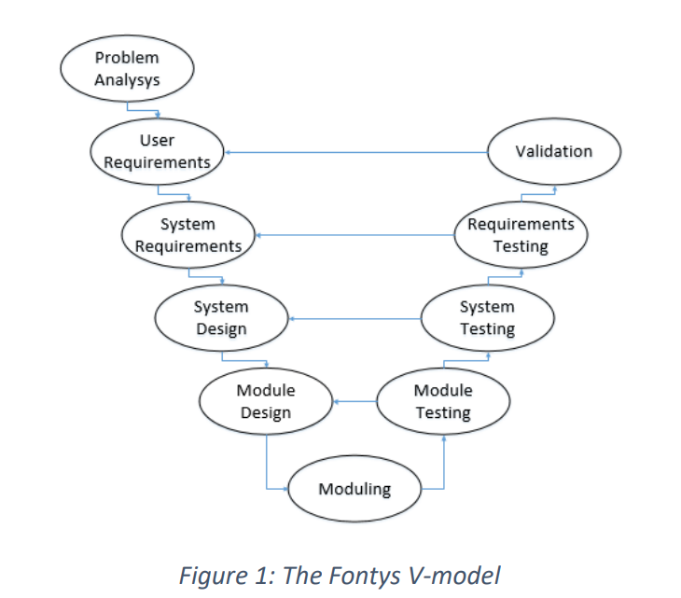
Figure A.1 Fontys V-Model Representation

Left Side: Development Phases
- Requirement Analysis
  - Define user needs and expectations.
  - Translate them into clear, measurable objectives.
- System Requirements
  - Develop SMART (Specific, Measurable, Achievable, Relevant, Time-bound) system requirements.
  - Plan verification and testing strategies.
- System Design
  - Create high-level and low-level designs.
  - Define system architecture, interfaces, and components.
- Module Design
  - Decompose the system into modules.
  - Specify the internal logic and functionality of each module.
- Moduling (Implementation)
  - Implement individual modules based on design.
  - Develop functional code, electrical wiring, or physical components.

Right Side: Testing & Validation Phases
- Module Testing
  - Test individual units for functionality.
  - Perform isolated tests to validate correctness.
- System Testing
  - Integrate modules and test the full system.
  - Validate that the system performs as intended.
- Acceptance Testing
  - Verify the system against user needs.
  - Confirm readiness for deployment.
Benefits of the V-Model:
- Ensures traceability between phases.
- Facilitates early error detection.
- Supports documentation and validation at each step.

Source: Fontys University of Applied Sciences (n.d.). Project Methodologies: Fontys V-Model [Internal course material].

Appendix B: Documentation and Demonstration Links
- GitHub Repository (Full documentation, code, schematics):
https://github.com/anastasiia-gif/MiniFactoryTCF
- Video Demonstration of Initial System:
https://drive.google.com/file/d/1ZJF2yWcFKO-Ci0sih-L7UFD-6rw2ImP9/view?usp=drive_link
- Plan of Approach Document:
https://docs.google.com/document/d/14HsQP_w8iV-gljeJxEyFWhT0B6SlpbkzotrSrRQLILk/edit?usp=sharing
- Assembly manual: https://docs.google.com/document/d/1loEIo7aQlHCNWvezpFuo1hC8qLYhPY-sCpMDtRe_vX0/edit?usp=sharing
- Software guideline: https://docs.google.com/document/d/1KuuI0siui7qMMVfnmm_3Qqvq_9LCW6hrh1Kjbssk6QI/edit?usp=sharing
- The Chocolate Factory meeting agendas and minutes: https://docs.google.com/document/d/1RVtjMqRWwIJV07XwP2lUyPn0u-H_DmGNVulg1DG9pWQ/edit?usp=sharing
- Actemium progress meeting minutes: https://docs.google.com/document/d/1peqJUtAHGN1Mz67zfPw0DVnBd9VAEJV1NfSbu_jOtwA/edit?usp=sharing

Appendix C: Explanation of the MoSCoW Prioritization Method
The MoSCoW method is a requirement prioritization technique widely used in project management. It categorizes requirements into four priority levels:
- Must Have: Essential features without which the project will fail.
- Should Have: Important features that enhance the solution but are not critical.
- Could Have: Desirable but non-essential features that can be included if time/resources allow.
- Won’t Have: Acknowledged features that are excluded from the current scope.
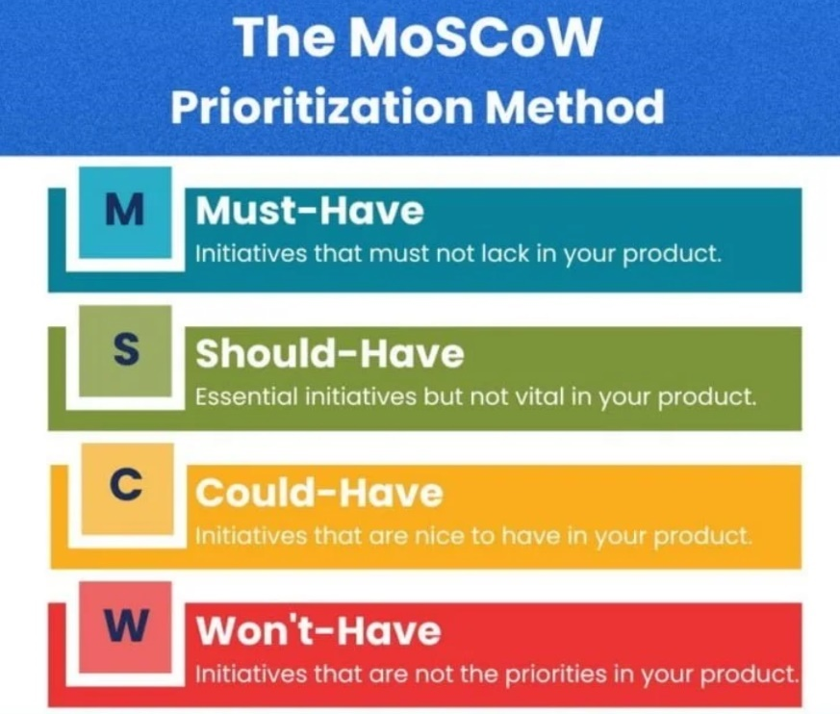
Figure C.1 MoSCoW Prioritization Chart
Benefits:
- Supports clear stakeholder communication.
- Helps manage scope and resources effectively.
- Aligns development focus with business value.
Source: Clegg, D., & Barker, R. (1994). Case Method Fast-Track: A RAD Approach. Addison-Wesley.

Appendix D: Functional Decomposition Based on ISA-88
This appendix provides a hierarchical breakdown of the Mini Factory based on the ISA-88 (IEC 61512) batch control standard. The structure allows for a clear understanding of how each system and subsystem functions within the complete process setup. This decomposition also forms the basis for future redesigns, testing, and documentation efforts.
According to ISA-88, industrial systems are divided into Enterprise, Site, Area, Process Cell, Unit, Equipment Module, and Control Module levels. For the purpose of this project, the decomposition begins at the Enterprise level (The Chocolate Factory) and focuses in detail on the Process Cell and below.

Hierarchy Overview
- Enterprise Level: The Chocolate Factory (Museum)
- Plant Level: Mini Factory (Exhibit installation)
- Process Cell Level: Individual processing stations/modules of the Mini Factory
- Equipment Modules: Logical groups of mechanical/electronic elements with a defined role
- Control Modules: Actuators, sensors, or devices controlled independently
Each section below outlines a process cell (e.g., Box Quality Check Conveyor), followed by its equipment modules and corresponding control modules (indented further).

Control Units
These are cross-cutting units responsible for the general operation of all process cells:
- Programmable Logic Controller (PLC)
- Pneumatic Control System
More technical details on these systems can be found in the Bosch Rexroth manuals (Appendix B).

User Interface (Figure D.1)
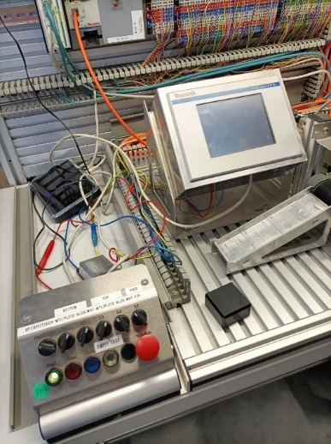
Figure D.1 User Interface Cell
- HMI (Human-Machine Interface)
- Control Panel
  - Start button
  - Stop button
  - Quit button
  - 6 mode switches
  - Empty tray button
  - Emergency stop

Box Quality Check Conveyor (Figure D.2)

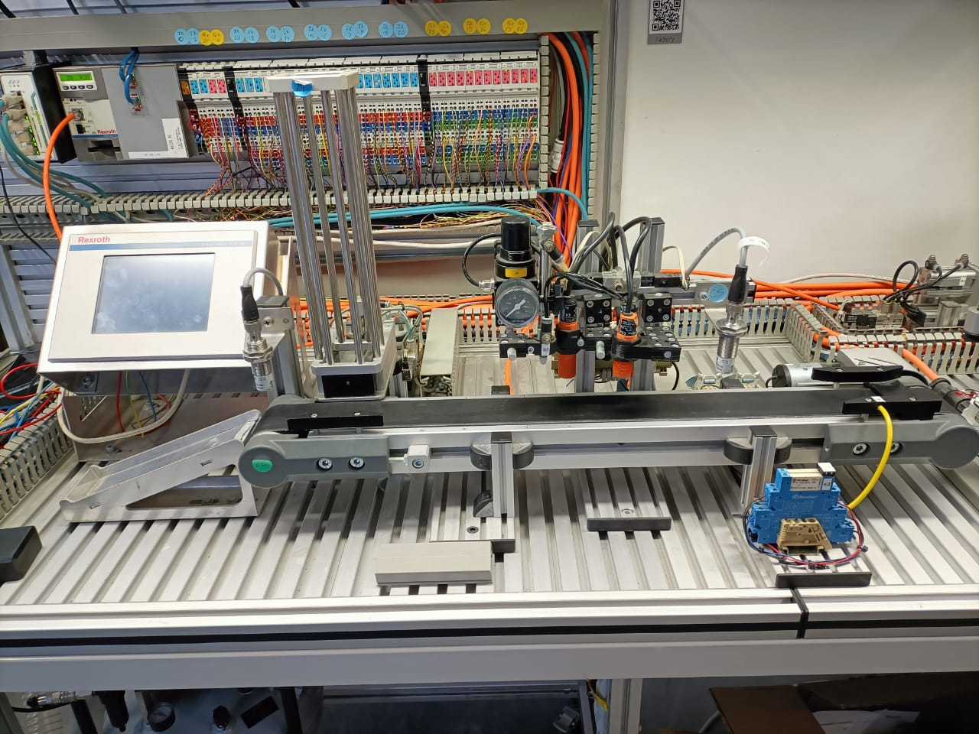
Figure D.2 Box Quality Check Conveyor
- Trash Tray
  - Slider
  - Stopper
- Conveyor
  - Motor
  - Conveyor belt
- Check System
  - Presence sensor
  - Depth sensor
  - Metal sensor
  - Barometer
- Box Intake
  - Box tower
  - Pneumatic pusher
  - Button actuator

Lock Placing System (Figure D.3)

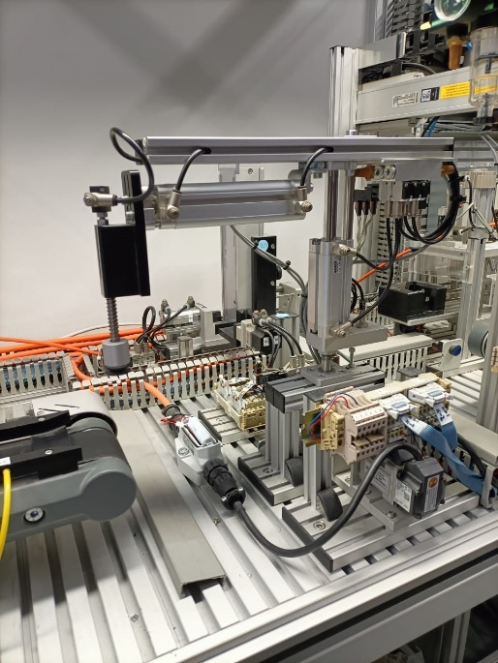
Figure D.3 Lock Placing System
- Box Side Rotator
  - Rotating platform
  - Motor
- Pin Placing Module
  - Pin storage
  - Box press
  - Pin press

Box Locking Press Station (Figure D.4)

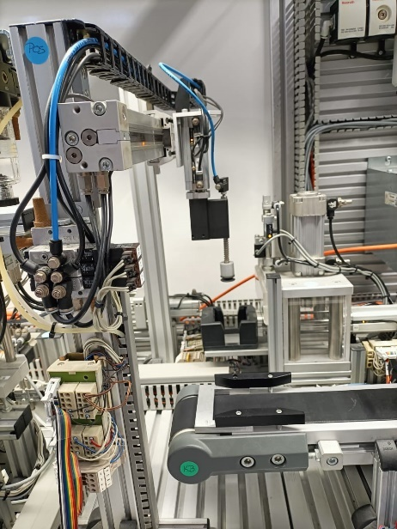
Figure D.4 Box Locking Press Pneumatics
- Robotic Arm Mover
  - Suction gripper
  - Motor
  - Up-down pneumatic cylinder
- Pneumatic Press
  - Box holder
  - Elongation axis
  - Pneumatic press actuator
- Hydraulic Press (Optional Mode)
  - Box holder
  - Elongation axis
  - Hydraulic press actuator
⚠️ Note: The system operates in only one press mode at a time — either pneumatic or hydraulic.

Final Box Placer (Figure D.5)

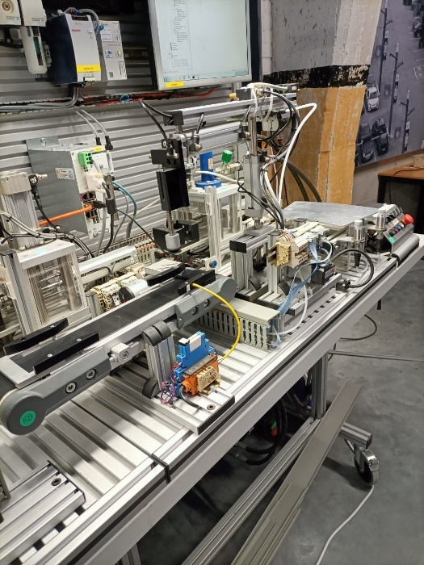
Figure D.5 Final Box Placer
- Final Conveyor
  - Metal bracket
  - Conveyor motor
  - Conveyor belt
  - Presence sensor
- Robotic Arm
  - Pneumatic suction
  - Elongator
  - Vertical cylinder
- Final Placement Table

Summary
This functional decomposition simplifies system understanding by mapping out how physical components relate to their control logic and operation within the overall exhibit. It serves as a guide for:
- System redesign and modular updates
- Testing and safety planning
- Educational documentation for future developers

Appendix E: ISA-88 model
This system is constructed according to the ISA S-88 decomposition (Figure E.1).
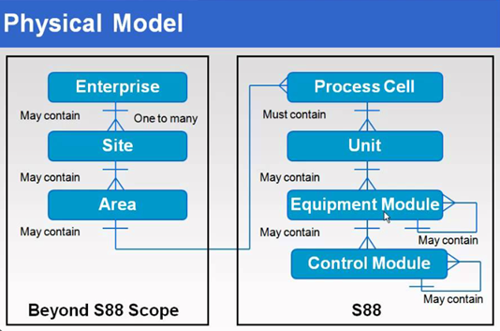
Figure E.1 Representation of functional decomposition according to the ISA S-88 model

S88, or ISA-88, refers to a set of standards developed by the International Society of Automation (ISA) for batch control systems in manufacturing processes. The physical aspect of S88 specifically pertains to the physical equipment and devices involved in a batch process.
In the context of S88, the physical model distinguishes and organizes the elements involved in a manufacturing process. This includes equipment such as tanks, vessels, valves, pumps, sensors, and other devices that play a role in the production of batches. The physical model helps define the structure and hierarchy of these elements within a batch system.
Functional decomposition in the context of S88, or ISA-88, involves breaking down a batch process into its functional elements to create a structured and hierarchical model. This approach allows for the systematic definition of operations, phases, and control activities within a batch system. Each functional element represents a specific task or action, such as material handling, equipment control, or data management. The functional decomposition approach emphasizes the modular design of control strategies, enabling the development of reusable and interchangeable control modules. By organizing the batch process into functional units, S88 facilitates a standardized and scalable framework that enhances the efficiency, maintainability, and flexibility of batch control systems across diverse industries and manufacturing environments.
The key levels in the S88 hierarchy are as follows:

Enterprise Level: at the top of the hierarchy is the enterprise level, which involves long-term planning, scheduling, and coordination of overall manufacturing activities. This level is concerned with business decisions and strategies related to production.

Site or Plant Level: the next level down is the site or plant level, where more detailed planning and scheduling occur. This level considers the overall resources, capacities, and capabilities of the manufacturing facility.
Area or Process Cell Level: this level represents a specific area or process cell within the plant where a batch process takes place. It defines the major production units or equipment involved in the process, such as reactors, mixers, or distillation columns.

Equipment Module Level: the control module level is where functional decomposition occurs. Each major phase or operation within the batch process is broken down into control modules. Control modules are the smallest functional units that encapsulate specific control and procedural logic for a particular task, such as material handling, heating, or mixing.

Control Module Level: at the lowest level of the hierarchy are equipment modules. These modules represent the physical devices and equipment associated with a specific control module. Equipment modules encapsulate the control functions needed to interact with the physical equipment, such as valves, pumps, or sensors.

Source: International Society of Automation. (2010). Batch Control Part 1: Models and Terminology (ISA-88.01-2010 / IEC 61512-1).

Appendix F: FMEA risk assessment
Failure Mode and Effects Analysis (FMEA) is a structured and systematic methodology used to identify, evaluate, and prioritize potential failures within a system, product, or process. Originally developed in the aerospace and manufacturing industries, FMEA is now widely applied in engineering projects to improve safety, reliability, and performance, particularly during the design and development phases.
The main goal of FMEA is to anticipate potential failure modes before they occur and to implement preventive measures that reduce risk to users and stakeholders. It helps project teams focus on the most critical areas of concern by quantifying risk using a numerical scoring system.
Key terms:
- Failure Mode: The specific way in which a component, system, or process could potentially fail to perform its intended function.
- Effect of Failure: The potential consequences of the failure on the overall system or user.
- Severity (S): A numerical score (from 1 to 10) that indicates the seriousness of the failure effect. A score of 10 represents a hazardous or life-threatening consequence.
- Occurrence (O): A numerical score (from 1 to 10) estimating the likelihood that the failure will occur. A higher value means a greater chance of occurrence.
- Detection (D): A numerical score (from 1 to 10) representing how likely it is that the failure will be detected before it causes harm. A lower score means the failure is easier to detect early.
- RPN (Risk Priority Number): A calculated score used to rank the risks, obtained by multiplying Severity, Occurrence, and Detection:
RPN = S × O × D
How FMEA supports this project

In the context of this project—adapting the Bosch Rexroth Mini Factory for safe and engaging educational use—FMEA is used to:
- Identify potential hazards related to mechanical, electrical, and user interface components.
- Evaluate the severity and probability of risks, especially considering child interaction.
- Prioritize which risks need mitigation through design changes, safeguards, or operational procedures.
- Collaborate with safety specialists to ensure compliance with child-friendly and museum safety standards.
Source: Stamatis, D. H. (2003). Failure Mode and Effect Analysis: FMEA from Theory to Execution. ASQ Quality Press.

Appendix G: Risk assessment Table (ISO 12100)
This appendix presents the complete risk assessment matrix conducted as part of the safety planning process for the Bosch Rexroth Mini Factory. The assessment follows the methodology outlined in the international safety standard ISO 12100: Safety of Machinery – General principles for design – Risk assessment and risk reduction.
The goal of this analysis is to identify, evaluate, and prioritize hazards that could arise during system use—particularly in a public, child-oriented educational setting. For each identified hazard, the following are specified:
- Hazard Description: Nature and source of the risk
- Affected Components: Relevant system elements (mechanical, electrical, etc.)
- Severity (S): The impact level of the hazard (scale 1–10)
- Occurrence (O): Likelihood of the hazard occurring (scale 1–10)
- Detectability (D): Likelihood that the hazard will be detected before harm (scale 1–10)
- Risk Priority Number (RPN): Product of S × O × D
- Proposed Mitigation Measures: Technical or procedural actions to reduce the risk
The risks were evaluated based on foreseeable misuse scenarios defined in Chapter 4.1.1 and operational parameters outlined in Chapter 4.1. Results from this assessment inform the safety measures described in Chapter 4.3 and are directly linked to the following system requirements:
- MSR.1 – Mechanical safety standards
- ESR.1 & ESR.2 – Electrical safety and user protection
- TSR.1 – Safety-focused testing and validation procedures
Note: Hazards with an RPN above 100 are considered high-risk and require immediate action or design intervention. Medium-risk hazards (RPN 50–100) should be mitigated where feasible. Low-risk items (RPN < 50) may be monitored or addressed via procedural controls.

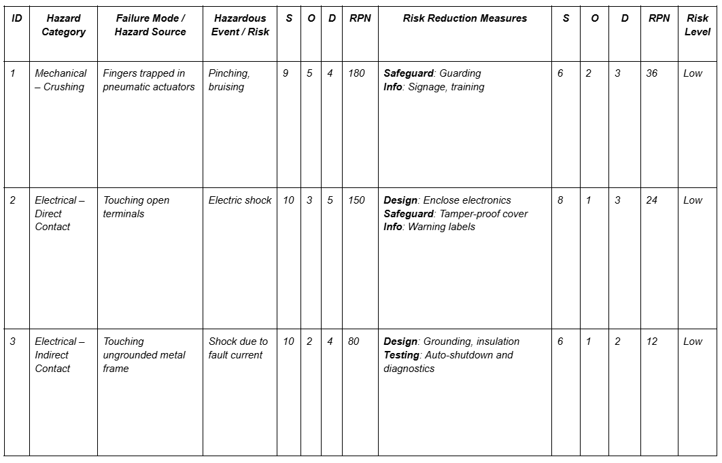
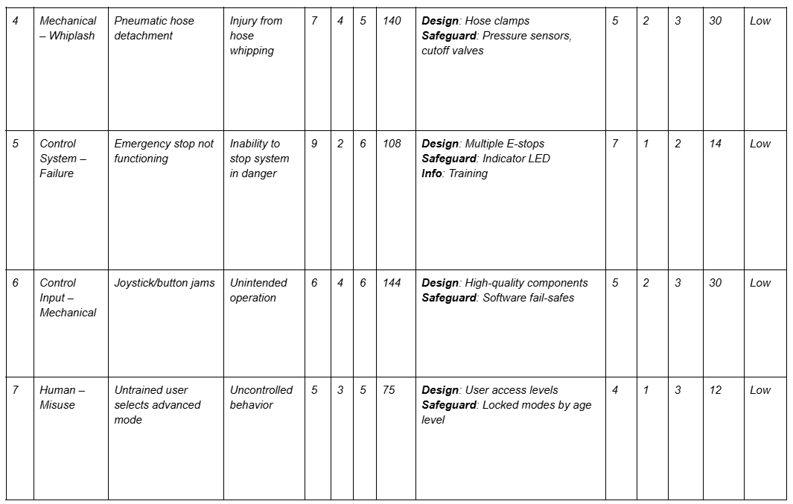

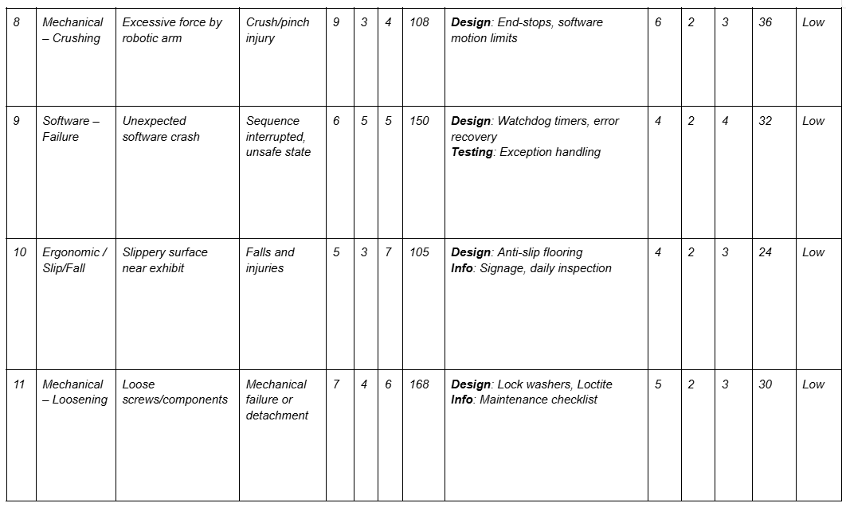
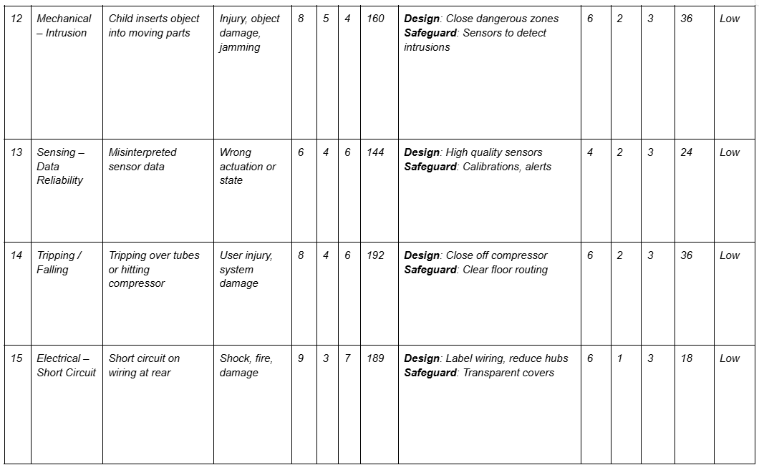

Appendix H: Maintenance Forms and Reports
To ensure the Mini Factory remains safe, functional, and engaging for all users—particularly children—a structured maintenance documentation system has been developed. This appendix contains the standardized forms and reporting templates used to track, evaluate, and optimize the system’s upkeep throughout its lifecycle.
The documentation serves multiple purposes:
- To verify compliance with ISO 12100, ISO 13849, and preventive maintenance principles as per IEC 60204-1.
- To provide traceability and accountability for all maintenance activities.
- To assist future operators and technicians in detecting trends, addressing emerging faults, and planning upgrades.
The following tools are included:
- Annual Maintenance Summary Report
A comprehensive yearly overview of system reliability, maintenance events, critical failures, recurring risks, and budgetary considerations. This summary helps supervisors and stakeholders make informed decisions about system improvements or part replacements.
- Maintenance Checks Form
A checklist-format sheet used during periodic inspections to record the condition of each key system component, from PLCs and pneumatic tubing to safety devices and 3D printed covers. Each entry includes task frequency and responsible personnel.
- Maintenance Log
A technician-level logbook for tracking individual maintenance events. This allows precise documentation of task execution, observed issues, resolution steps, and personnel involvement. The log is essential for ensuring continuity and transparency across shifts or teams.
These documents are intended to be used iteratively throughout the year, forming the basis for validation, audit-readiness, and future training initiatives. Blank versions are provided and can be printed or digitized as needed.
Annual Maintenance Summary Report

1. System Overview
System Name: Bosch Rexroth Mini Factory
Location: [Insert location]
Year: 2025
Responsible Supervisor: [Insert Name]
2. Summary of Performed Maintenance
Total routine inspections completed: ___
Number of component replacements: ___
Total downtime due to maintenance: ___ hours
Emergency maintenance cases: ___

3. Notable Incidents or Repairs
Date | Issue Reported | Component | Resolution Action | Downtime (hrs) | Remarks

4. Trends & Risk Observations
- Recurring issues: (e.g., frequent air leaks in pneumatic tubing)
- Components showing early wear: (e.g., joystick buttons degrading quickly)
- Safety system performance: (e.g., 100% E-stop functionality verified monthly)

5. Recommendations
- Replace [Component X] in Q3 due to wear.
- Budget required for spare parts: €___
- Suggested upgrades: [e.g., light curtain integration, improved joystick material]

6. Training & Documentation
- Number of staff trained on safety procedures: ___
- Documentation updates made: [List documents updated or added]
Maintenance checks form
Component/System | Task Description | Frequency | Responsible Role | Checked (✔/✘)
PLC & I/O Modules | Inspect wiring, check LEDs, test communication | Monthly | Electronics Technician
 | Backup PLC program | Annually | Electronics Technician
Compressor Unit | Check for leaks, pressure, temperature | Weekly (Visual) | Maintenance Technician
 | Drain moisture from tank | Monthly | Maintenance Technician
 | Replace air filter | Every 6 months | Maintenance Technician
Pneumatic System | Check tubing, cylinder/valve response | Bi-weekly | Maintenance Technician
 | Lubricate moving parts | Every 6 months | Maintenance Technician
Hydraulic Pump & Press | Check fluid levels, leaks, press movement | Monthly | Certified Technician
 | Change hydraulic oil | Annually | Certified Technician
 | Check pressure settings | Quarterly | Certified Technician
Safety Devices (E-Stops etc.) | Test response, check wiring and contacts | Weekly | Safety Officer / Technician
Transparent Covers & Screens | Clean, inspect for cracks or warping | Monthly | Maintenance Team
Structural Frame & Table | Tighten bolts, check for wear and instability | Monthly | Maintenance Team
Wiring & Cable Management | Inspect for damage, loose connectors | Monthly | Electrical Technician
User Interface / Buttons | Test responsiveness, look for damage | Weekly | IT / Maintenance Team
3D Printed Parts & Covers | Check for cracks, deformation | Quarterly | Maintenance Team
General Cleaning | Wipe surfaces, user touchpoints | Weekly | Museum Staff / Hosts
Maintenance log
Date | Component/Area | Task performed | Issue | Action taken | Technician name | Sign

Appendix I: User story
What is a User Story?
A User Story is a concise, informal description of a feature or functionality written from the perspective of the end user. It is commonly used in Agile software development to capture user requirements in a simple and understandable format. A typical user story follows the structure:
As a [type of user], I want [an action] so that [a benefit/a value].
For example:
As a visitor, I want to choose a learning level so that the content is suitable for my age and experience.
Why Are User Stories Important?
User stories help development teams understand the real-world needs of users and focus on delivering value. Their key advantages include:
- User-Centric Development: They ensure the product is built around the user's needs and experiences.
- Simplified Communication: They bridge the gap between technical teams and non-technical stakeholders.
- Incremental Delivery: They allow features to be delivered in manageable iterations, supporting Agile release planning.
- Clear Prioritization: User stories help teams prioritize work based on value and impact.
How Do User Stories Work?
User stories are typically gathered during the early stages of a project and refined over time through collaboration between developers, designers, and stakeholders. Once written, stories are:
- Grouped into Releases – Stories are categorized by functionality or priority and organized into development cycles or sprints.
- Broken Down into Tasks – Developers decompose each story into technical tasks or subtasks.
- Reviewed and Tested – Once implemented, stories are reviewed for completion and tested for user satisfaction.
User stories may also include acceptance criteria, which define the conditions under which the story is considered complete. This helps ensure quality and alignment with user expectations.
Source: Fontys University of Applied Sciences (n.d.). Project Methodologies: User story [Internal course material].

Appendix J: Pages design
Figma link to the design: https://www.figma.com/design/H6kHGFZW4rLogu5M2iiK09/MiniFactory?node-id=0-1&t=DzG7h03NYrhDLx07-1

Start page
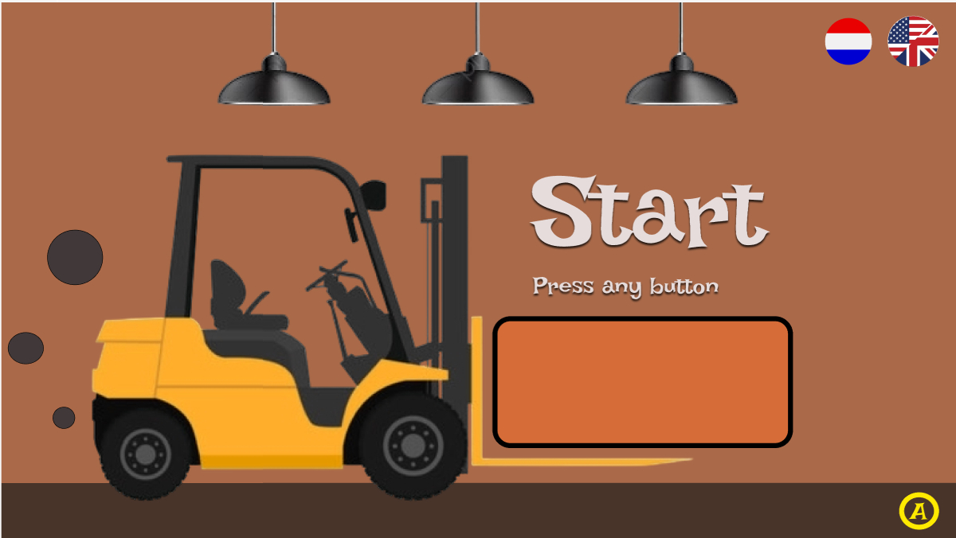

Introduction page
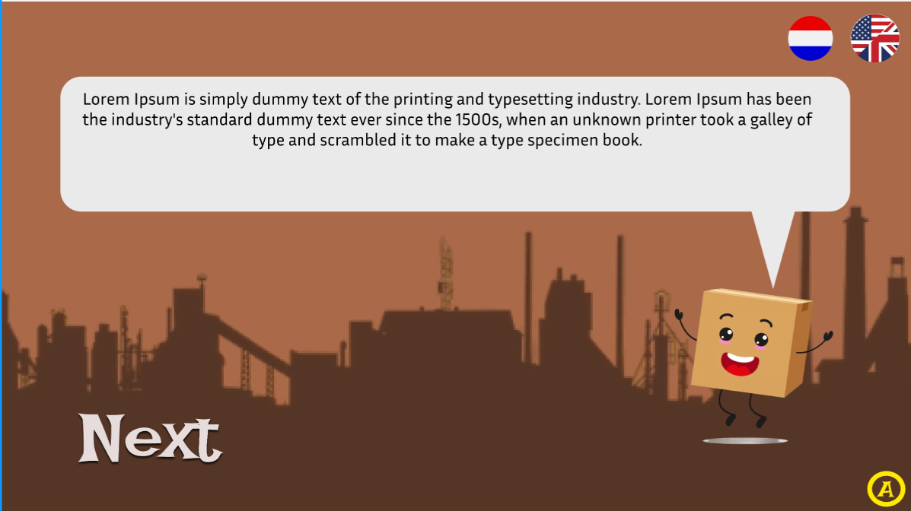

Choose level page
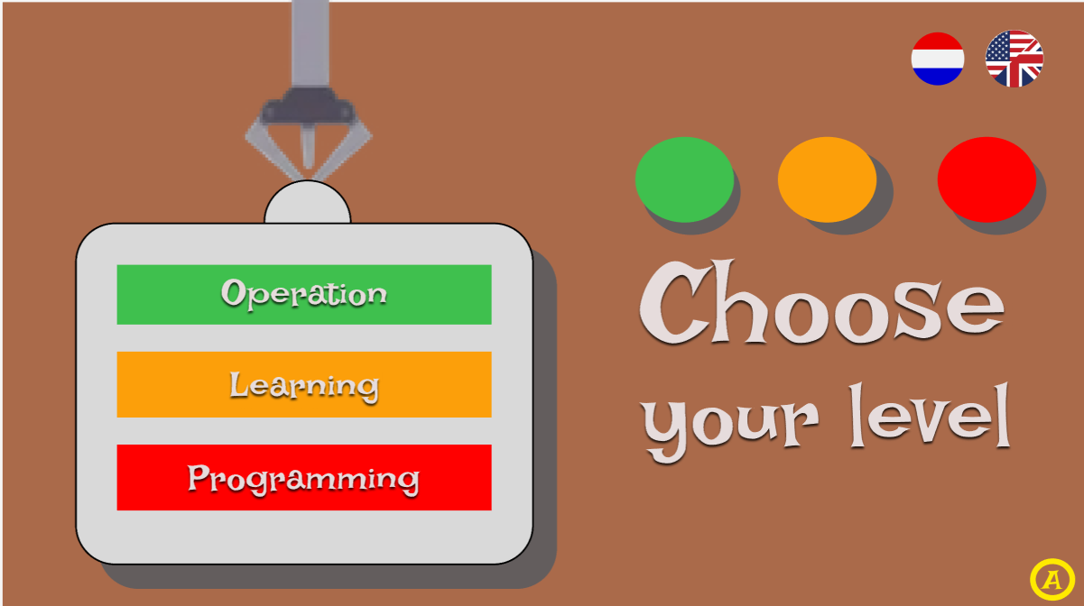

Out of order page
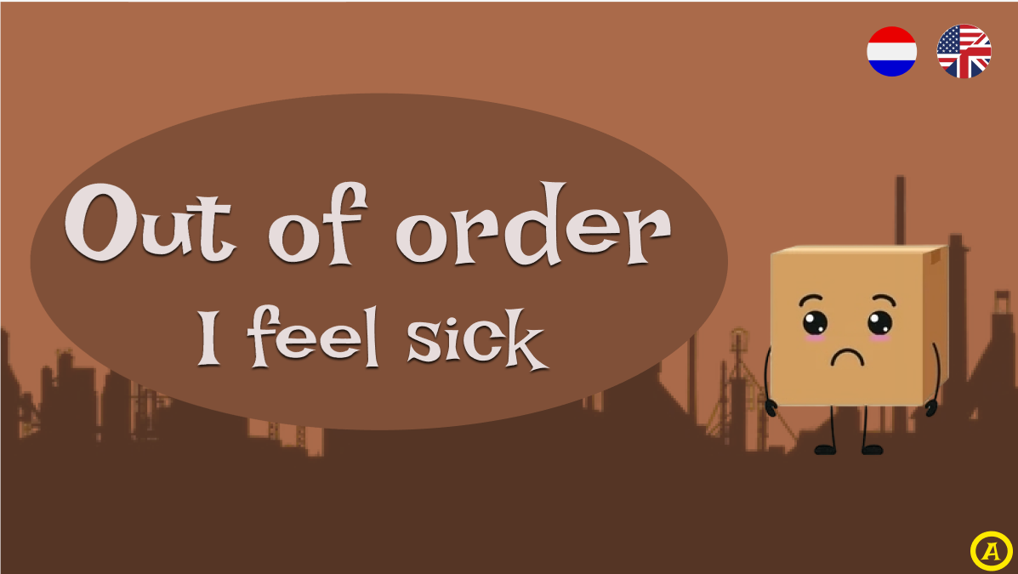

Error page
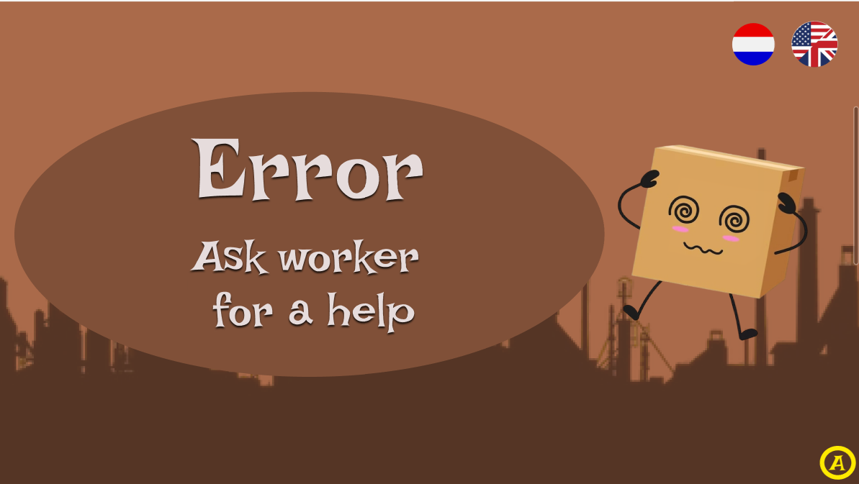

Admin access form
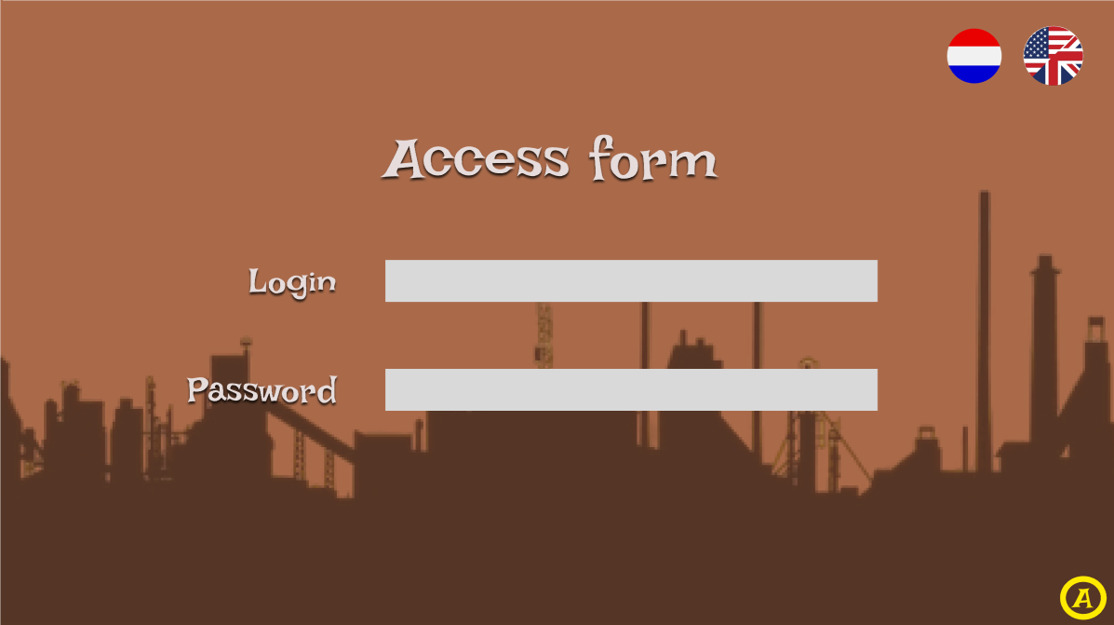

Learning page (going to be more)
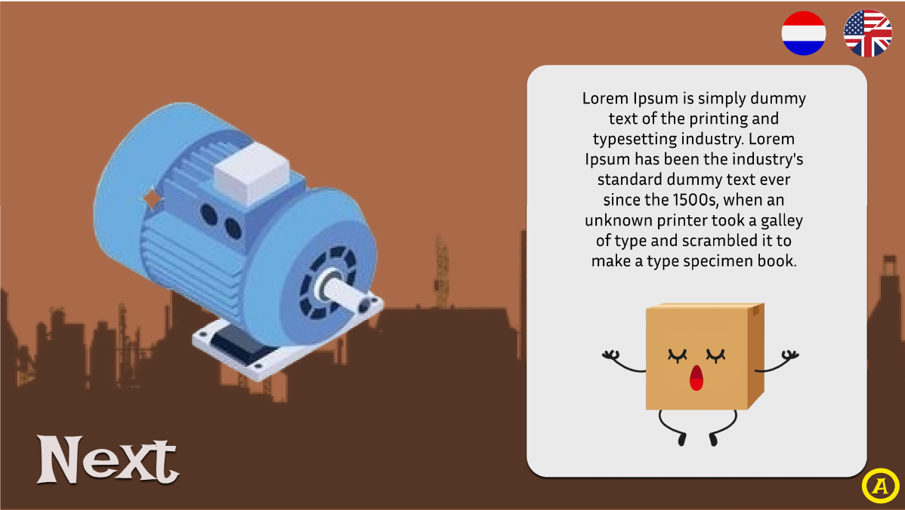

Programming page (approximate design)
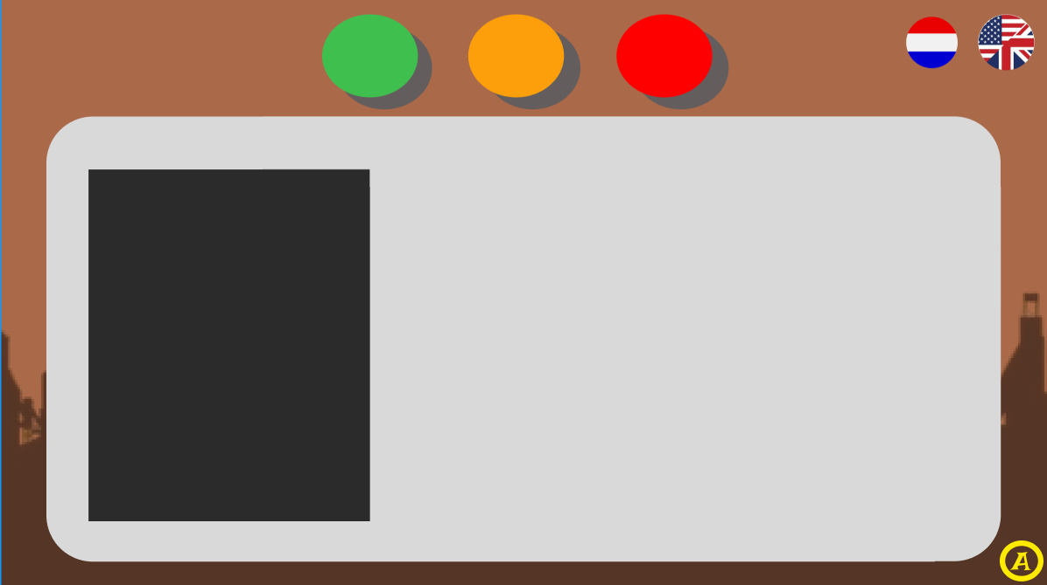

Tutorial programming page style (is going to be more of them)
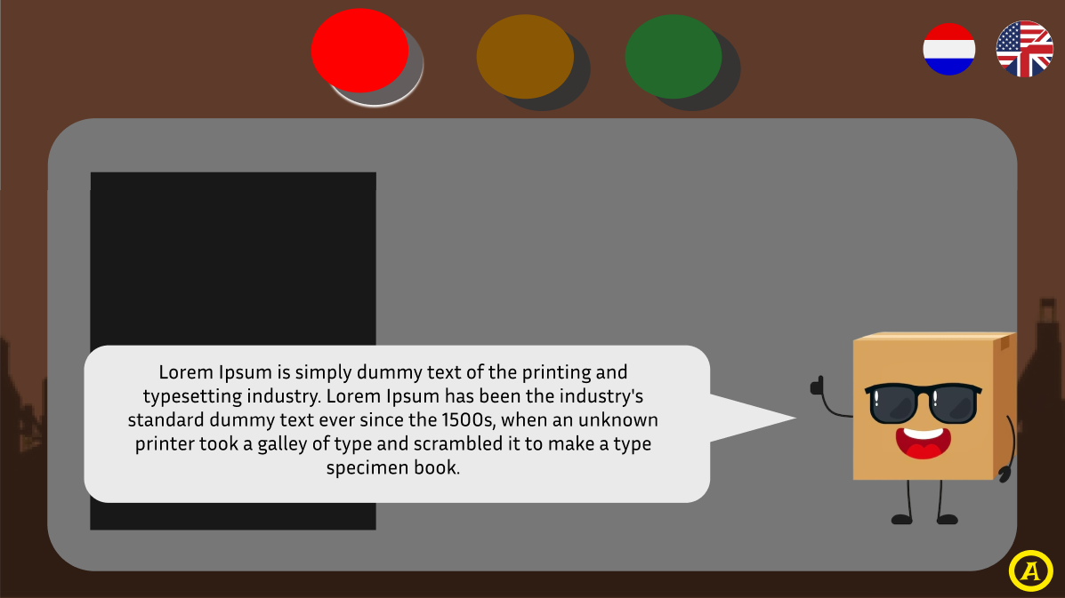

Document Revision The following revision numbering is applied to this document: Revision (or Rev.): GGRR For new project documents, the revision number is 0000. Revisions for approval, the revision number is GGRR in which GG = 00 to 99 and RR = 01 to 99. Approved revisions, the revision number is GG00 in which GG = 01 to 99.

